P2: Ideation + 3 Alternatives

H06

Team UI French Fry

Emma Hanson, Erin Kim, Hye Lim(Hannah) Kim, Philena Yang, Zehao(Tim) Tan

Table of Contents

| Project Description and Requirements Summary   * Project Description * Requirements Summary | 3  3  3 |
| --- | --- |
| Design Space   * Process * Requirements * Initial Design Alternatives * Design Space Analysis | 5  5  6  7  10 |
| Prototypes   * Design Alternative 1: Website * Design Alternative 2: Mobile Application * Design Alternative 3: Flyer w/ Text Service | 11  11  16  22 |
| Design Assessment  Reflection  Appendices | 29  30  32 |

# Project Description and Requirements Summary

## Project Description

In our analysis of the problem space in part 1, we considered data from various sources, including ACFB’s website, surveys with proxy users in the community, interviews with an ACFB representative and a MealsOnWheels volunteer, and studies regarding transportation and food insecurity in the Atlanta area. From these sources, we found that accessibility was a big issue for food insecure people in metro Atlanta and areas outside of Atlanta. Data showed that food insecurity is fastest growing in rural areas of Atlanta, where there is little public transportation and issues of internet access. From our proxy surveys, we found that 30% of respondents don't have reliable transportation and 50% walk to their nearest grocery stores. These findings highlight the need for the distribution of food and resources to food insecure people with issues of mobility, especially the elderly, children, or those with disabilities. The current system includes public transportation, limited delivery services, and popup food pantries. The service aims to support accessibility needs by establishing an Atlanta Community Food Bank delivery service in and outside of metro Atlanta, bridging the gap between food insecure people and the food that ACFB provides. The intended tasks that the service would support include requesting deliveries and communicating with ACFB to coordinate optimal delivery times and locations. The intended user population is the same as in our part 1, in which our primary user group is food insecure people with transportation/mobility issues and ACFB. Many of the food insecure people are elderly, disabled, or children, and would interact with the system to communicate and receive food from ACFB. Secondary user groups that include ACFB volunteers and tertiary user groups that include ACFB donors would be affected as well.

## Requirements Summary

**Functional**

* Information collection: The system’s main functional component will be to set up a method for food insecure people to receive ACFB’s food services. Requirements include gathering user information, including name, location, contact, food preferences, and availability. For delivery, users will request ACFB’s delivery services and their information will be stored somewhere such as a database, with users being able to update their information as it changes.
* Availability feedback: The system must also be able to inform users whether delivery is available to them based on their location and the availability of volunteers/drivers and supply of food. This information should be queried from another database to determine whether the delivery is available.

**Non-Functional**

* Usability: The system interface must facilitate the process of requesting food delivery for food insecure people. The interface must be understandable to all users and the information and actions should be presented clearly.
* Utility: The system must be useful for food insecure people. Food delivery should improve access to ACFB’s food services for many in the community. The interface should allow users to receive useful information and feedback from the information they input.
* Accessibility: The system interface must be accessible to as many food insecure people as possible. Technological constraints involving those that don’t have access to the Internet or a smartphone or computer need to be considered in designing the prototype.
* Reliability: The system must be reliable for its users. Because it is a food delivery system, an error can result in food insecure people not receiving food and not being able to eat.

# 

# 

# 

# Design Space

## Process

Before finalizing the 3 interface designs for our project, we went through the process of completing class participation and studio assignments to brainstorm potential interface designs. We individually thought of interfaces that could solve a task identified by Persona 1 from our P1 report and used the Crazy 8’s method to sketch 8 distinct interface designs in 8 minutes.

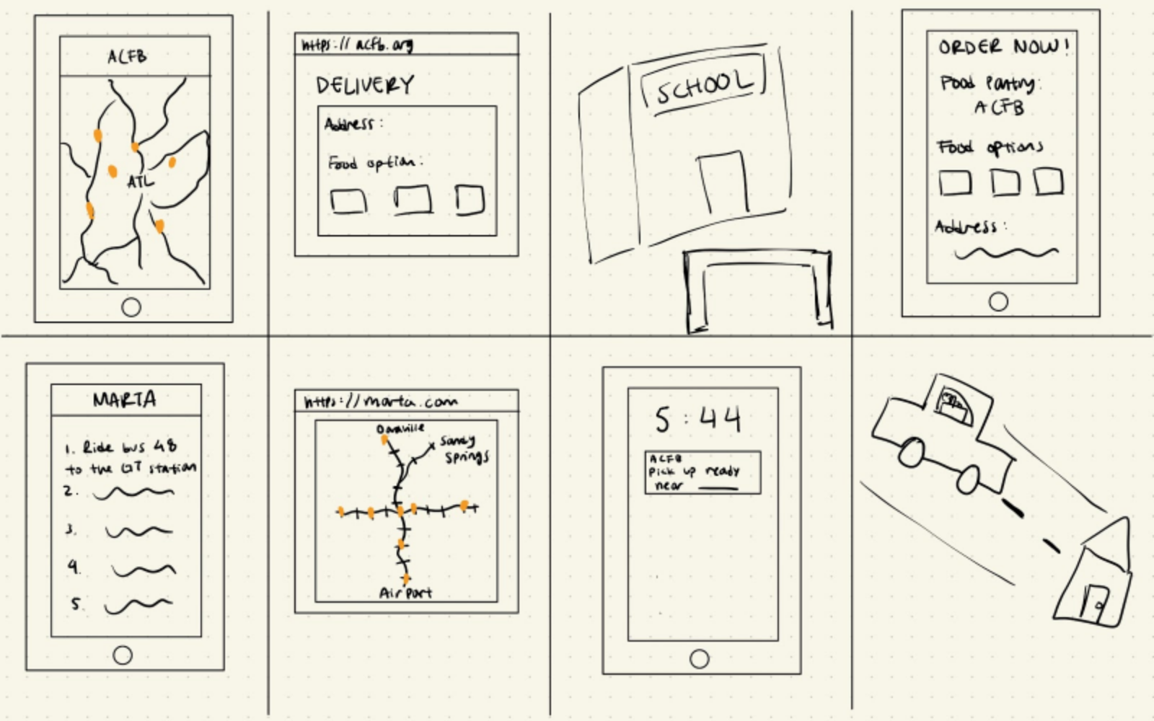 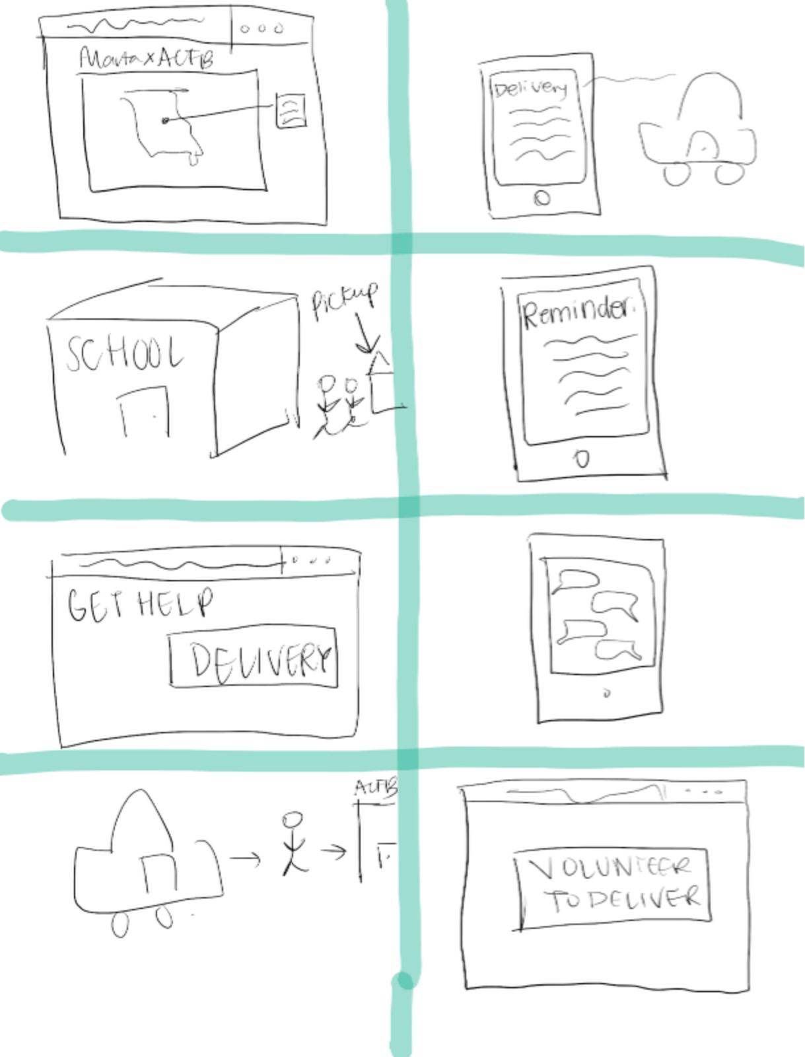

Figure 1. Hannah’s Crazy 8’s interface ideas Figure 2. Philena’s Crazy 8’s interface ideas

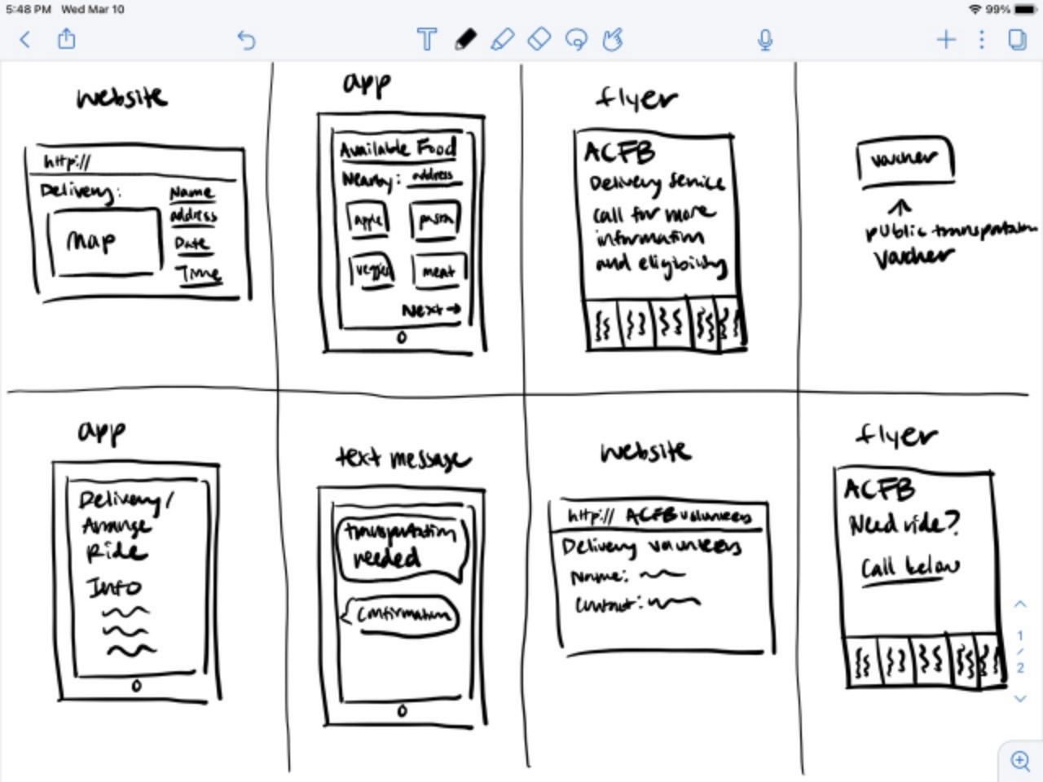 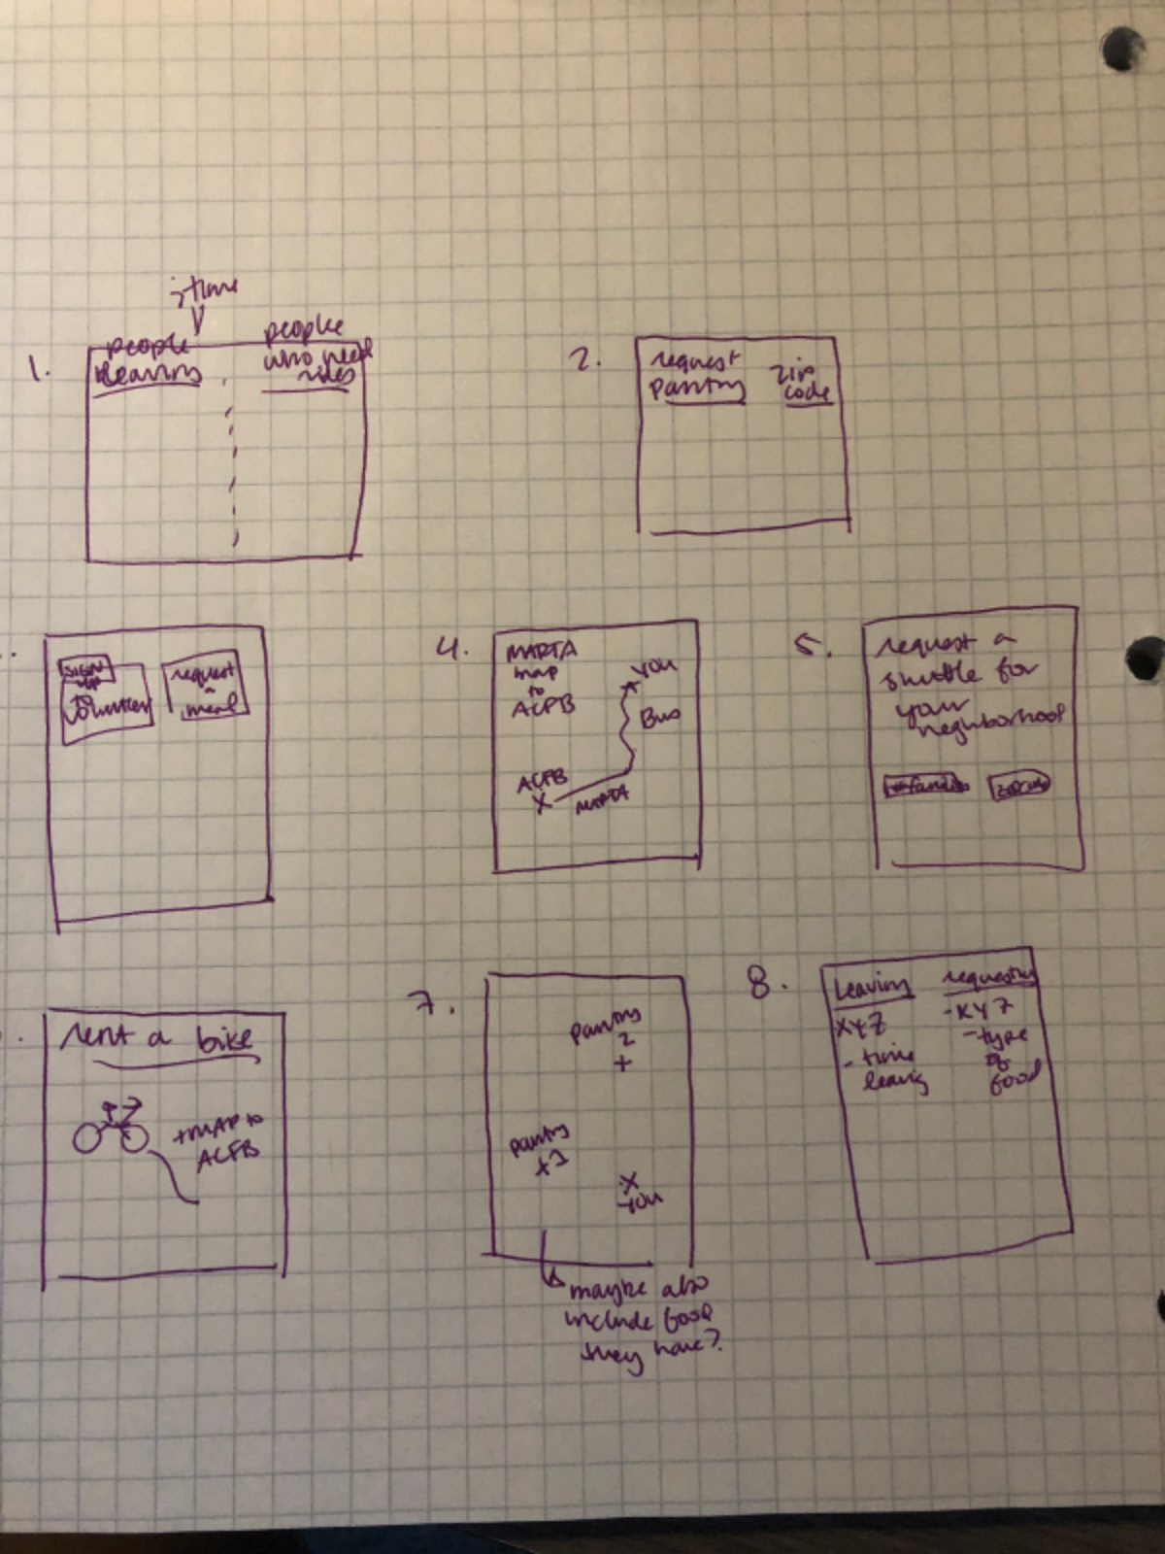

Figure 3. Erin’s Crazy 8’s interface ideas Figure 4. Emma’s Crazy 8’s interface ideas

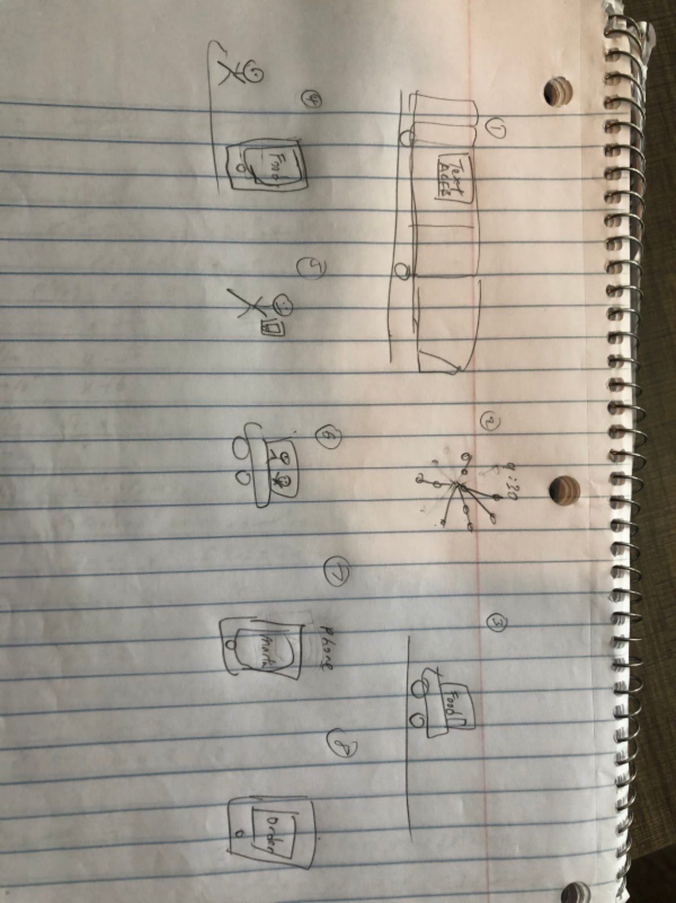

Figure 5. Tim’s Crazy 8’s interface ideas.

After brainstorming individually, we collected our ideas together and organized the ideas by solution and then by medium to identify common solutions.

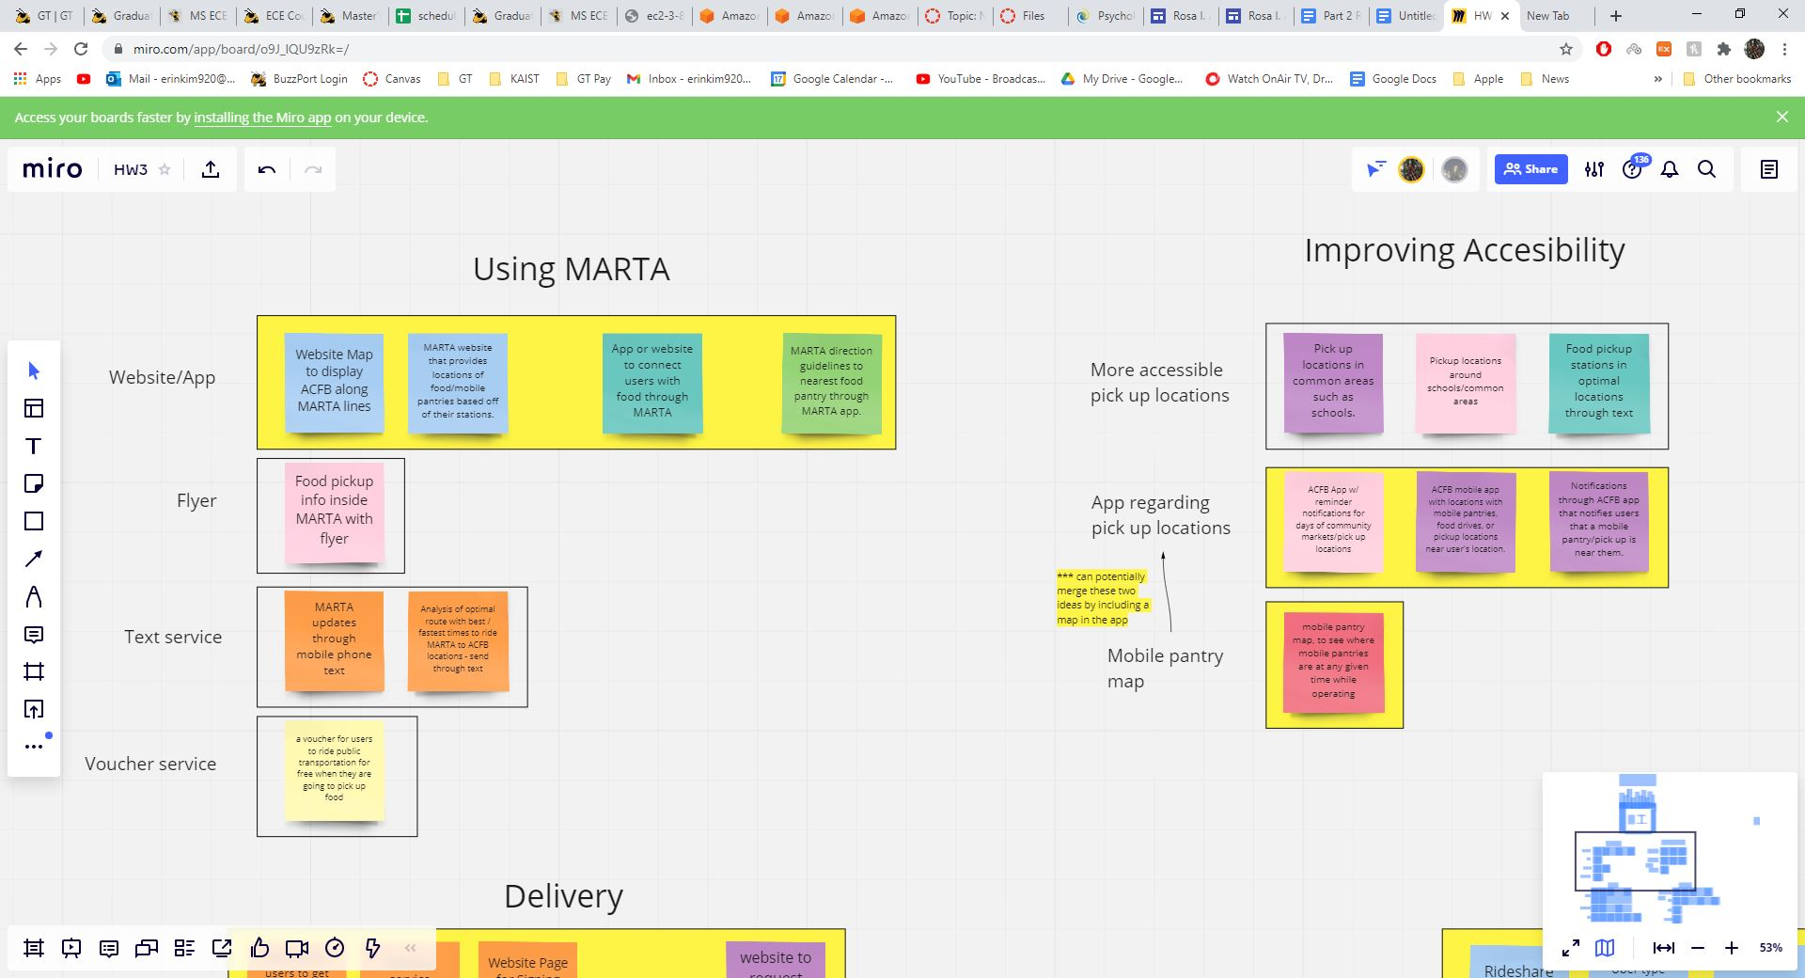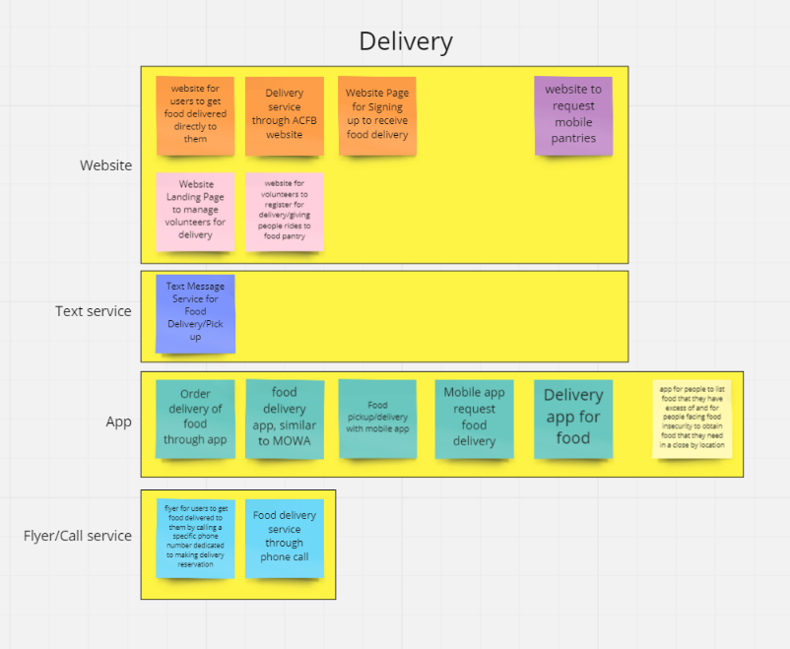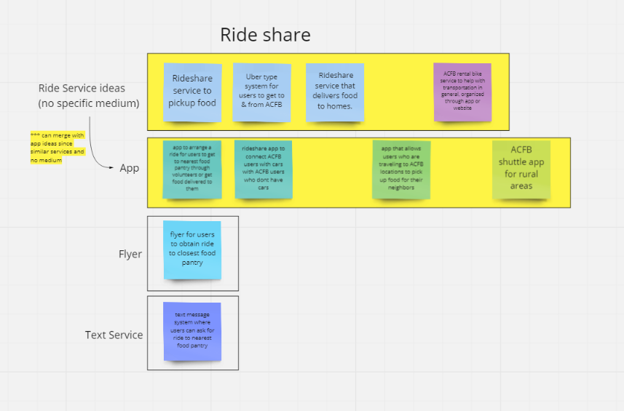

Figure 6. A Miro Board where we organized our ideas as a team by solution and then by medium, highlighting the ideas we planned to pursue.

By doing the Crazy 8’s activity individually, we were able to quickly sketch the ideas we were thinking of throughout the process of understanding the problem space. After collecting our ideas and organizing them into one space, we were able to identify common ideas we had and discuss the different functions of these interfaces. Although there were common mediums for ideas, each team member had a different idea of how the interface would function and its purpose. Through these activities and discussions, we were able to combine different ideas to develop a better interface design and finalize which designs met our requirements and usability goals. We decided on 7 different design alternatives and went through the process of discussing each design, including their benefits and tradeoffs, to decide which 3 designs best fit the needs of the user and the requirements we have set.

## Requirements

Some requirements that may be difficult to realize include accessibility and reliability. We want our system to be accessible to as many people facing food insecurity as possible while still being a reliable system for its users. The more analog the approach of our system is, the harder it will be for the system to be reliable and not result in errors. Compared to an interface that requires technology like a website, an interface like a call system would result in more errors because a human is taking the call and recording the information compared to a website obtaining and recording the information. There are bound to be more human errors than technological errors. However, the more technological a system becomes, the less accessible it will be for our users. Many people facing food insecurity do not have the money to purchase smartphones or other technologies. Therefore, even if we create a highly reliable system, many users may not be able to utilize it.

## Initial Design Alternatives

Before focusing on a single solution for our problem space, we brainstormed 7 main interface designs, organized above in Figure 6.

1. Flyer for food delivery
2. Website for food delivery
3. Mobile Application for food delivery
4. Text service for food delivery
5. Mobile Application for MARTA
6. Mobile Application for ACFB mobile pantry locations
7. Mobile Application for Ride service

Before deciding on which mediums would work the best, we decided to focus on a single solution and develop different interface designs based on this solution. The solutions we developed for our problem space are food delivery, using MARTA more effectively, making mobile pantries more accessible, and a ride service.

**Food Delivery**

One solution we came up with is creating a food delivery service to make food more accessible to those who do not have a means of transportation. Although it would provide a solution for those who do not have a means of transportation or have a disability, it would be hard to manage without enough volunteers willing to deliver to homes.

**MARTA**

Another solution we came up with is making MARTA more accessible to those facing food insecurity by having a system that tells the user where the closest available food pantry is by MARTA. Although it would help users identify places to obtain food by MARTA, it wouldn’t be an ideal solution because MARTA is not accessible to people outside of the urban area.

**Mobile Pantry**

Another solution we came up with is making mobile pantries more accessible to those facing food insecurity by having a system that tells the user where the closest available mobile pantry is being held. Although it would help users identify places to obtain food, it would be meaningless if the user is too far from the nearest mobile pantry, and they would still be facing the problem of no transportation.

**Ride Service**

Another solution we came up with is creating a rideshare service that will help provide rides for users who do not have a means of transportation to the closest food pantry. A rideshare service will solve the solution of transportation, but it would be hard to implement if there are not enough users with cars who are willing to give rides.

After considering each of the solutions, we came to the conclusion that a food delivery service would be the best solution to our problem space. Creating a system that uses MARTA to show the closest food pantries and uses the mobile pantries more effectively would help promote these options, but these solutions would only help a portion of users rather than all. Although preparing a ride service could also be a good solution, it would be easier to recruit more volunteers to deliver than recruit users who have cars and are willing to give rides.

Finally, we discussed the pros and cons of different mediums for a food delivery service.

1. **Flyer**
   1. **Description**: creation of a flyer that has information regarding the food delivery service and contact information to sign up for the service and for more information
   2. **Pros**: easy to understand, most users have access to a phone (public or personal),
   3. **Cons**: would need to place in areas where many users congregate, not very sustainable and could easily be destroyed, hard to track delivery
2. **Website**
   1. **Description**: expansion of the ACFB web application for users to sign up for the food delivery service and keep track of their delivery
   2. **Pros**: accessible to many users through public computers in libraries and community centers, easy to maintain and keep track of deliveries
   3. **Cons**: hard to track delivery if user doesn’t own computer
3. **Mobile Application**
   1. **Description**: creation of a mobile application for users to sign up for the food delivery service and keep track of their delivery
   2. **Pros**: easy to track delivery, easy to maintain and keep track of deliveries
   3. **Cons**: not all users have smartphones, resource-extensive to develop
4. **Text service**
   1. **Description**: expansion of the ACFB texting service for users to sign up for the food delivery service and keep track of their delivery
   2. **Pros**: easy to use, simple in design, easy to track delivery
   3. **Cons**: not all users may have phone with texting capabilities

## Design Space Analysis

By discussing the pros and cons of each design alternative, we were able to determine which alternatives are feasible and best fulfill our design requirements. Some requirements of our system that could be difficult to realize would be that the system must be accessible to as many people facing food insecurity as possible while still being a reliable system for its users. Furthermore, the system we develop must be usable and easy to understand for all users, and it must be able to track the delivery for users to be updated, to know when it is going to be delivered, and to get notifications of delays or changes.

In terms of tradeoffs, we plan to explore the tradeoffs between a system that updates delivery information through technological means versus one that requires human action to be updated, and we plan to look at tradeoffs between creating an entirely new system versus expanding on an existing system.

When comparing each of the interfaces, we realized that a mobile application and text service would track delivery much easier than a website and flyer would. In return, a website and flyer would be more accessible to our users in signing up for delivery than a mobile application or text service would. For all designs, we considered both the pros and cons to decide on our alternatives.

## Final Design Alternatives

Using these criteria, we were able to narrow our initial design alternatives down to 3 interface designs.

1. **Website**
   * expansion of the ACFB web application for users to sign up for the food delivery service and keep track of their delivery
2. **Mobile Application**
   * creation of a mobile application for users to sign up for the food delivery service and keep track of their delivery
3. **Text Service**
   * expansion of the ACFB texting service for users to sign up for the food delivery service and keep track of their delivery

# Prototypes

## 

## Design Alternative 1: Website

*(Integrated into existing ACFB website)*

This design alternative is a web page for Atlanta Community Food Bank that would allow users to sign up for one-time or recurring food delivery services. This would alleviate transportation issues faced by users through circumventing the need for them to find their own transportation. This prototype would be helpful based on evidence from P1 (see appendix B), including data from the survey sent out to proxy users which showed that most proxy users without cars preferred to have food delivered to them as an alternative to walking or taking public transportation. This prototype would be especially useful in more suburban and rural areas, where forms of transportation such as walking and public transportation are less useful. We found during our research for P1 that food insecurity is growing the most in these areas of Atlanta. The interview with the Atlanta Community Foodbank also showed that a large majority of users are children and those with disabilities, both of whom lack access to transportation. By including a delivery system onto the ACFB website would be helpful in that users already know how to access and navigate the website, and by adding a new button for delivery next to the donations button would allow users to easily access the delivery tab. This design alternative helps ACFB in reaching their goal of eliminating hunger in Atlanta and throughout Georgia by bringing in more primary stakeholders, those who are food insecure, through the expanded accessibility by providing a delivery service.

**Stakeholders:**

* Primary: ACFB Users(Food Insecure), Volunteers who deliver, Organizers behind the delivery system, ACFB
* Secondary: Children in food insecure families, rideshare drivers
* Tertiary: People who donate to ACFB

**Iteration 1:**

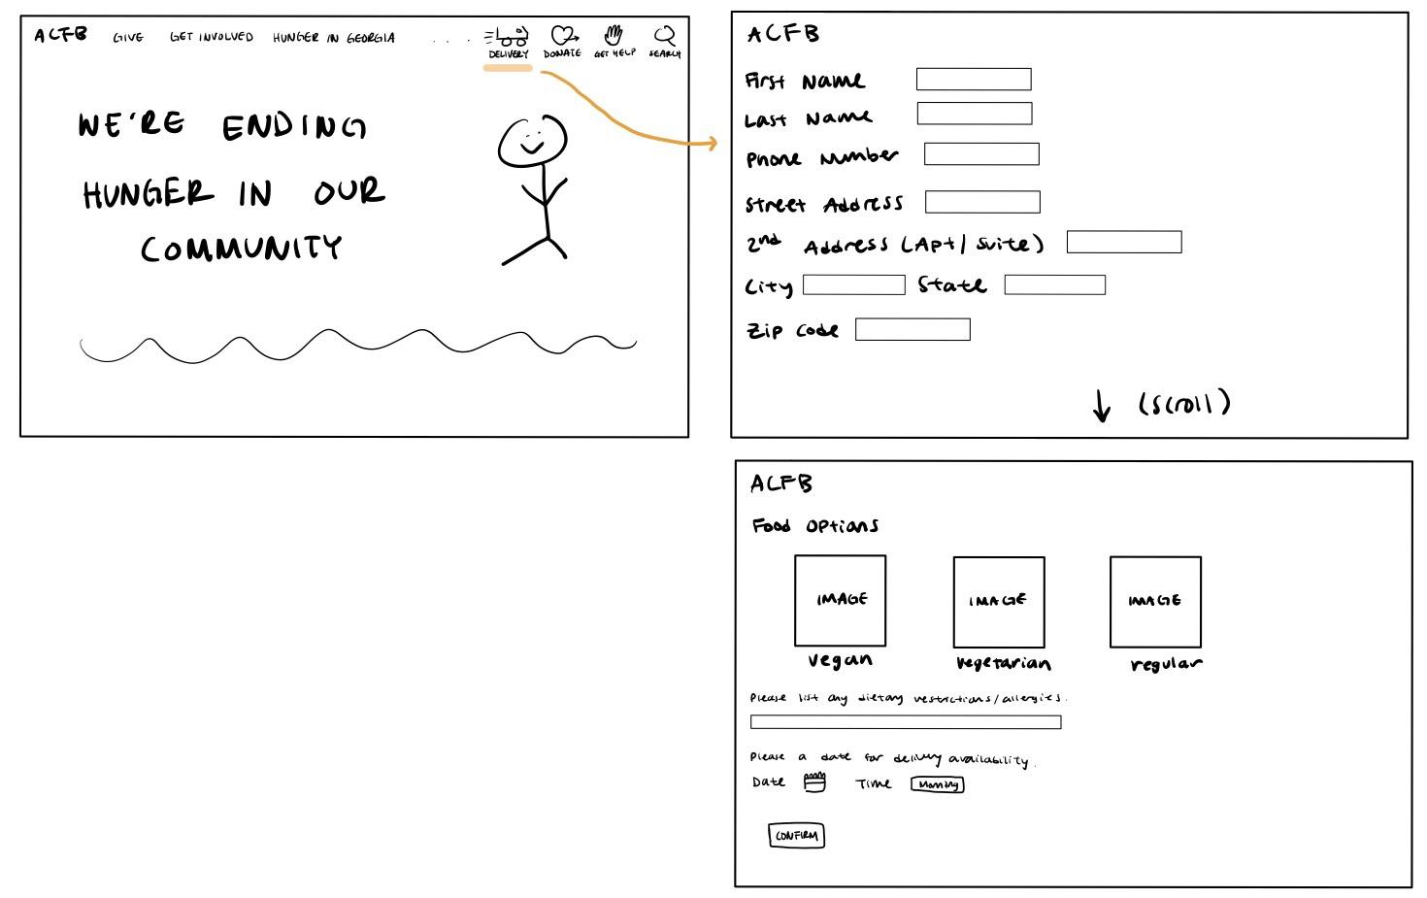

We created a simple sketch for our first iteration where we added an extra button on the main home page next to the donation, get help, and search buttons for users to easily find and access the delivery option. Having a truck icon as the delivery button allows users to easily understand that it is associated with delivery, especially for users who may not be able to read English, keeping the consistency of good visibility that ACFB’s website already had. When users click on the delivery button, it will lead them to a separate page where they fill out their personal information (all required) including name, phone number, street address, city, state, and zip code, food option, and when they would like their food delivered. Users will be able to choose vegan, vegetarian, and regular food options and list out any dietary restrictions or allergies in order to meet user needs.

**Iteration 2:**

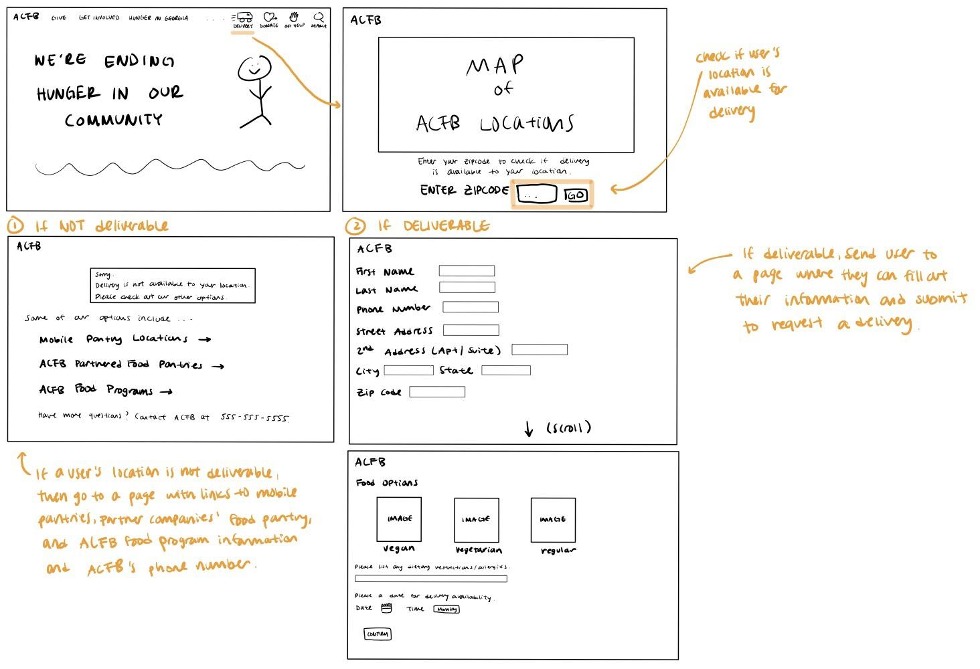

In our second iteration, we created another page where once you press the delivery button, it leads users to a page where it checks their zip code to check if their location is deliverable since ACFB cannot deliver to every location in Georgia. If the user’s location is not deliverable, then a they will be directed to a page that has a list of information where they could possibly obtain food from ACFB through either mobile pantries, ACFB pantries/food drives, ACFB partner pantries, and ACFB’s customer service phone number for any further questions users may have. By providing this list allows users to not feel discriminated against others who are able to have food delivered to their homes by showing the several alternate options of gathering food rather than having a page that simply says “Sorry, we do not deliver to your location.” If ACFB is able to deliver to the user’s location, then they will be directed to the page where they fill out their personal information and choose their food options and delivery time.

**Iteration 3:** 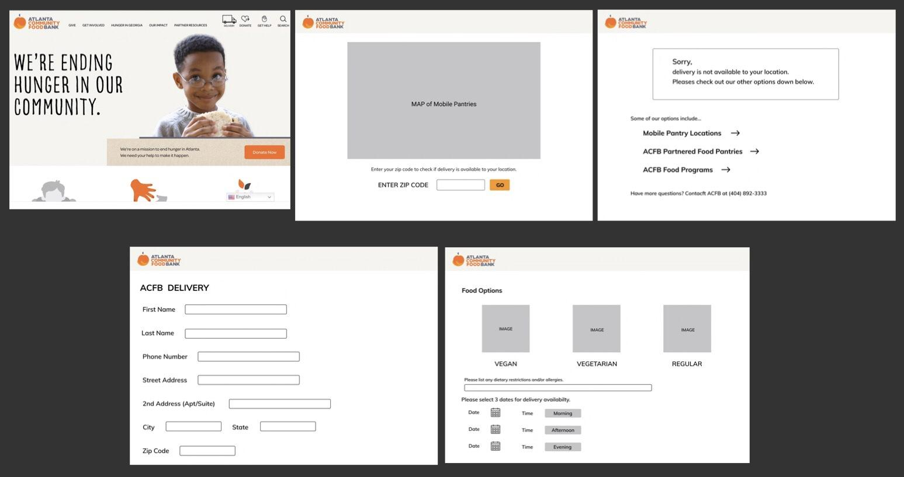

For our third iteration, we changed our design in order to be more convenient to our users. In our previous iterations, we only had one time slot for users to pick, but we found that users may find that time restricting, so we included 2 more days they could choose to have their food delivered. If they click on the calendar, they will be able to go through the months of the current year and by clicking on the day, the website will automatically get the information into its database. However, ACFB will not be able to delivery to all users’ at their preferred specific time as in hours and minutes, so instead we have created three options of morning, afternoon, and evening which will be shown as a dropdown once the user clicks on it, in order for ACFB to also be able to organize the deliveries that need to be made and create a delivery route that efficiently uses time and mileage.

**Storyboard:**

**Iteration 1:**

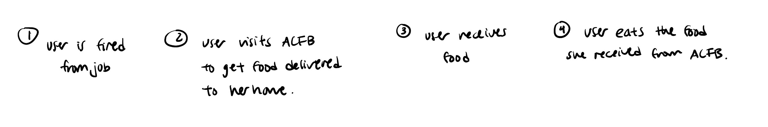

In our first iteration of our storyboard, we have listed out what we would sketch out in our storyboard. We included our primary stakeholder and the events she goes through that makes her use the delivery system ACFB offers, how she gets the food, and what she does with it.

**Iteration 2:**

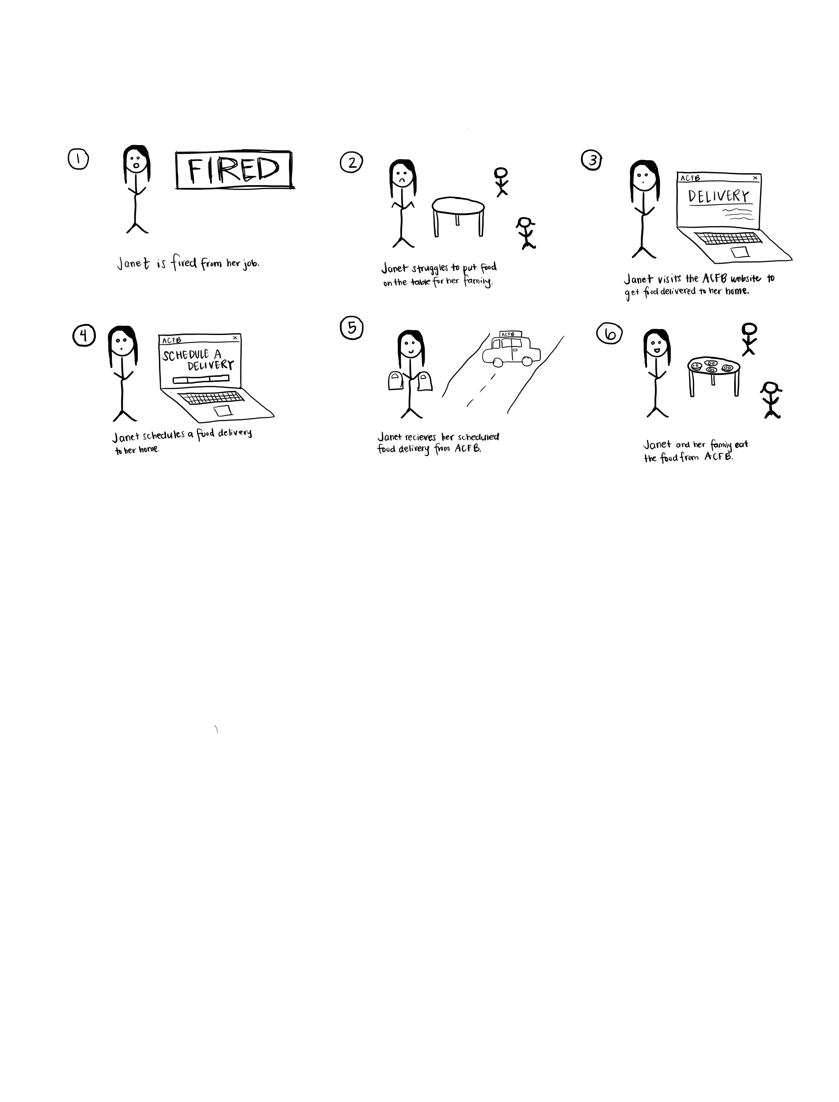

In our second iteration of our storyboard, we drew out our user scenario character’s, Janet, scenario. Unlike our first iteration, we added an additional scenario that includes her children in order to take into consideration other stakeholders and not just the primary stakeholder. Including other stakeholders allows the storyboard to be expanded and inclusive of other possible scenarios.

**User Scenario**

*Janet is a 22 year old single mother who lost her job in March 2020 due to the COVID-19 pandemic. She picked up two minimum wage part time jobs and sold her car in order to pay rent, so she and her two children have somewhere to live, but she has recently run out of savings and has had issues with getting food on the table. She does not have time to walk or take MARTA buses to pick up food from a food bank, however, due to her two jobs. Her children’s school has also gone online and does not offer a food pick up service for lunch where her children usually received free lunch off of the free and reduced federal meal program when school was in person. She discovered a food delivery service offered by Atlanta Community Food Bank that involves delivering food donated by volunteers regularly to her house, and even allows her to order food that her lactose intolerant son can eat without a problem. She goes online to ACFB.org to see how she can get her food delivered and finds out there is also a mobile app and text service. However, she had to sell her phone in order to pay off the extra internet bells because of her children using more internet data than usual in order to attend school. She clicks on the delivery button on the home page, checks to see if her location is deliverable, which it is, and fills out her personal information, food options, and makes sure to include that her son is lactose intolerant, and schedules three delivery dates through the ACFB website that correlate with her work schedule. An ACFB organizer takes Janet’s information and places them onto a spreadsheet with other users who also ordered a delivery service. This organizer then passes the route information to an ACFB delivery volunteer who takes the information and begins their delivery route. When he arrives at Janet’s home, he rings the doorbell, and Janet answers the door. Janet takes the food and thanks the delivery volunteer. Janet is able to feed her family nutritious meals nearly every night and is content with the ACFB service and leaves ACFB a 5 star review on Google.*

**Evaluating the Success of our Prototype:**

We will evaluate our prototype through testing proxy users’ experience as they interact with the prototype interface. We will accomplish this through asking proxy users to use our prototype to schedule food deliveries, and then ask them questions about the ease of use and how this application could benefit them. We will also record quantitative measures such as the number of clicks on the page in order to determine whether our application is easy to use. We can also record the number of successful delivery sign ups versus attempted delivery sign ups, and how likely proxy users would be willing to use an interface similar to our prototype.

## **Design Alternative 2: Mobile Application**

The mobile application would be an electronic application that would allow those who are food insecure to register and schedule food delivery to their home. We chose this design alternative because according to our survey results generated in P1(see appendix B), the internet and mobile devices were the most highly rated forms of technology that our users have access to. Both the internet and mobile devices rated at 30.09% of the most convenient technology that our users had access to leading us to believe a mobile application would be a good design alternative.

**Iteration 1:**

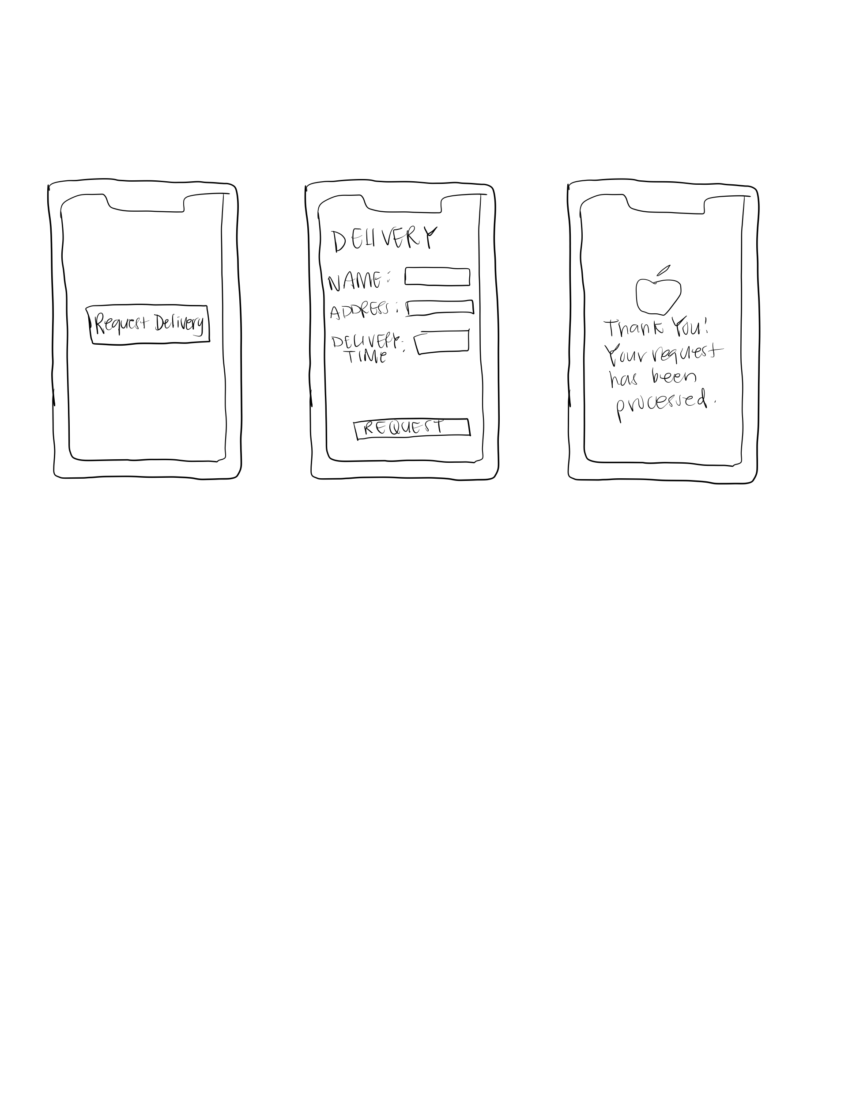

The first iteration of our mobile application was vertical and low fidelity. We sketched these via an iPad. The sketch was vertical because the focus of our mobile application was on delivery, so we wanted to first highlight what this process would look like. Registering for food delivery is seen through a simple “Request Delivery” button and is completed via the next two screens as shown above. We wanted to make this process as simple as possible in order to create a streamlined way to register for food that would not be complicated or timely.

**Iteration 2:**

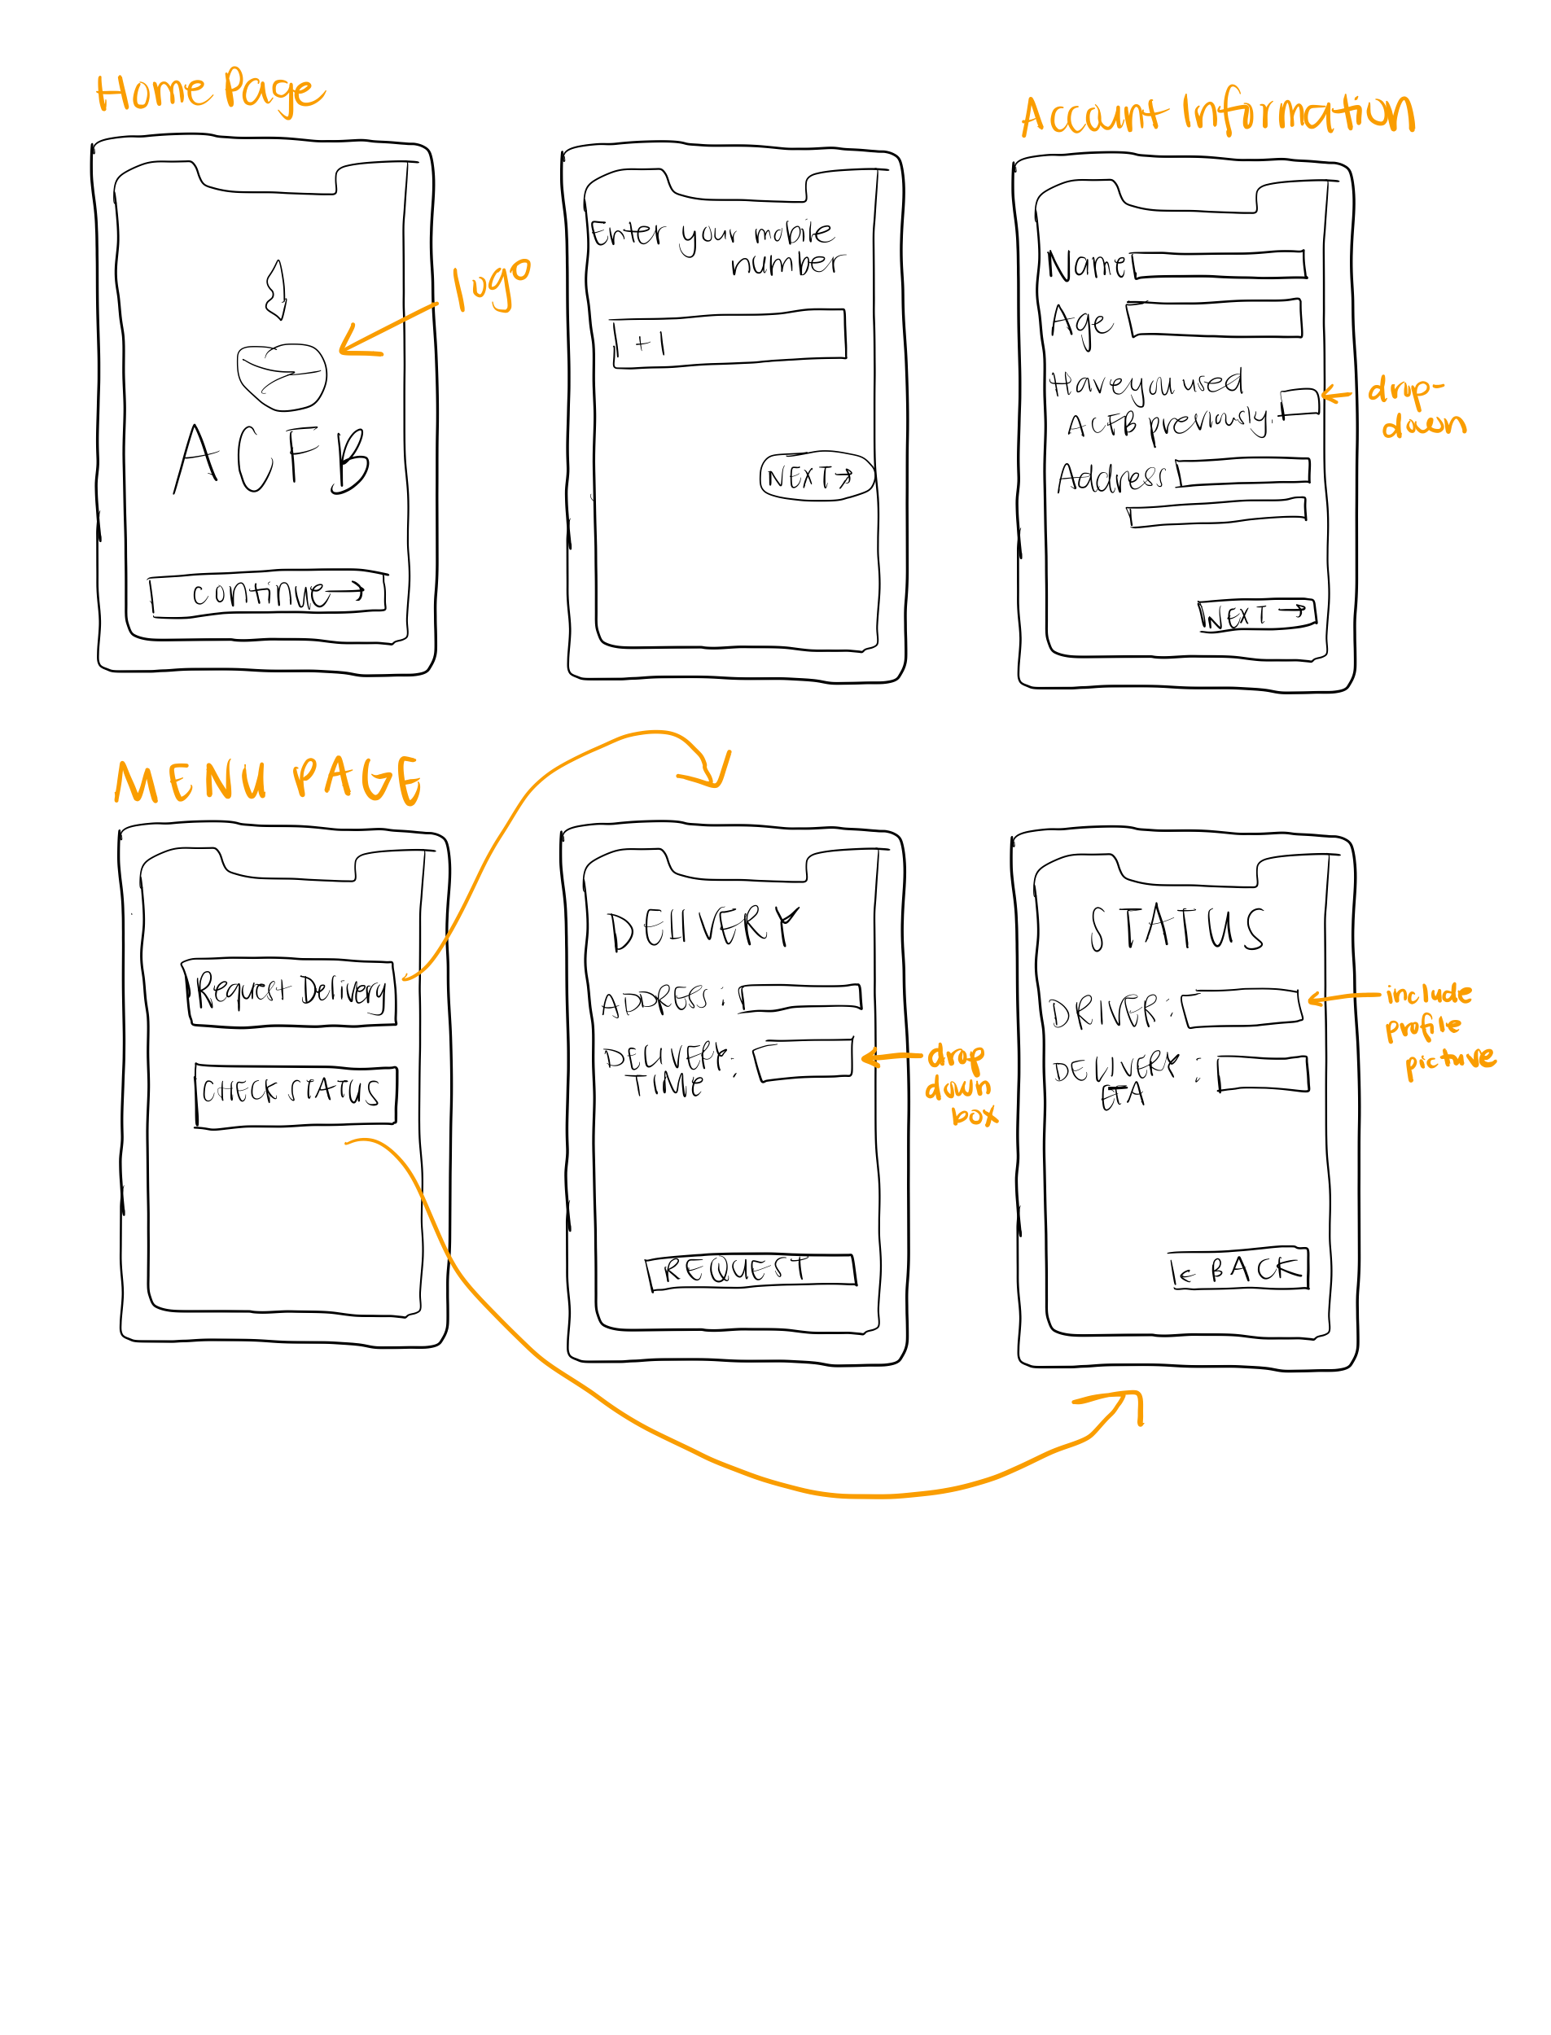

In the second iteration of the mobile application prototype, our design expanded both horizontally and vertically. In terms of designing the app horizontally, we decided to dive deeper into highlighting the two main components of our application: requesting a delivery and then checking on the status of a delivery request. We then expanded further into the actual steps of each task like asking users for their preferred delivery time. We also thought more intentionally about the flow of the application and decided to include screens for users to create accounts in order for their information to be stored, so ordering delivery services would not be repetitive in asking for the same information. In order to be recognizable with being associated with ACFB, we also added some branding like the ACFB logo for consistent branding and recognizability.

**Final Mockup:**

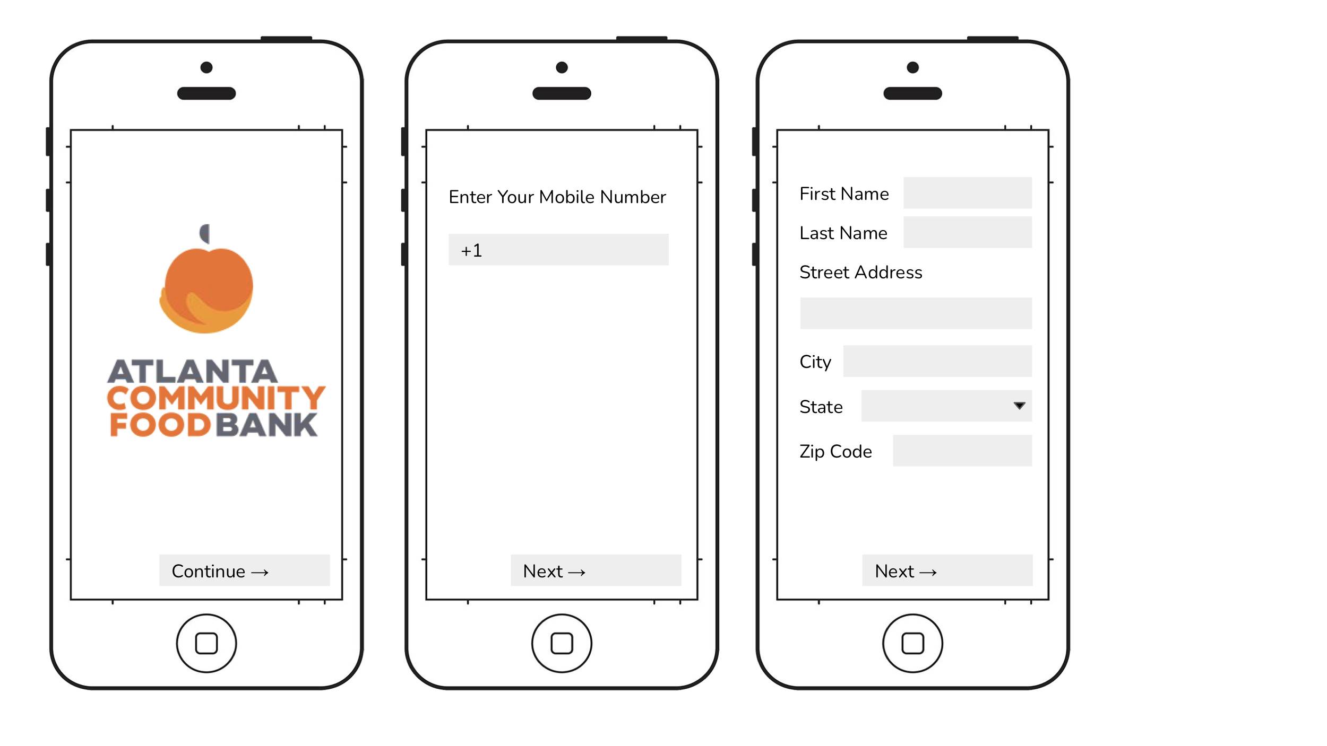

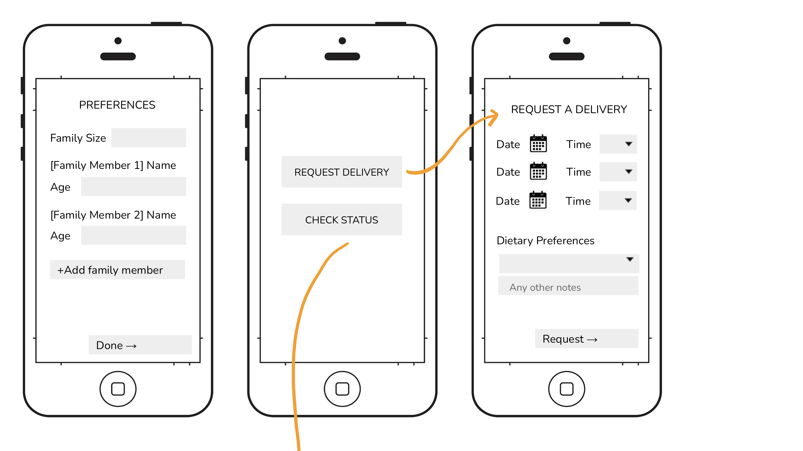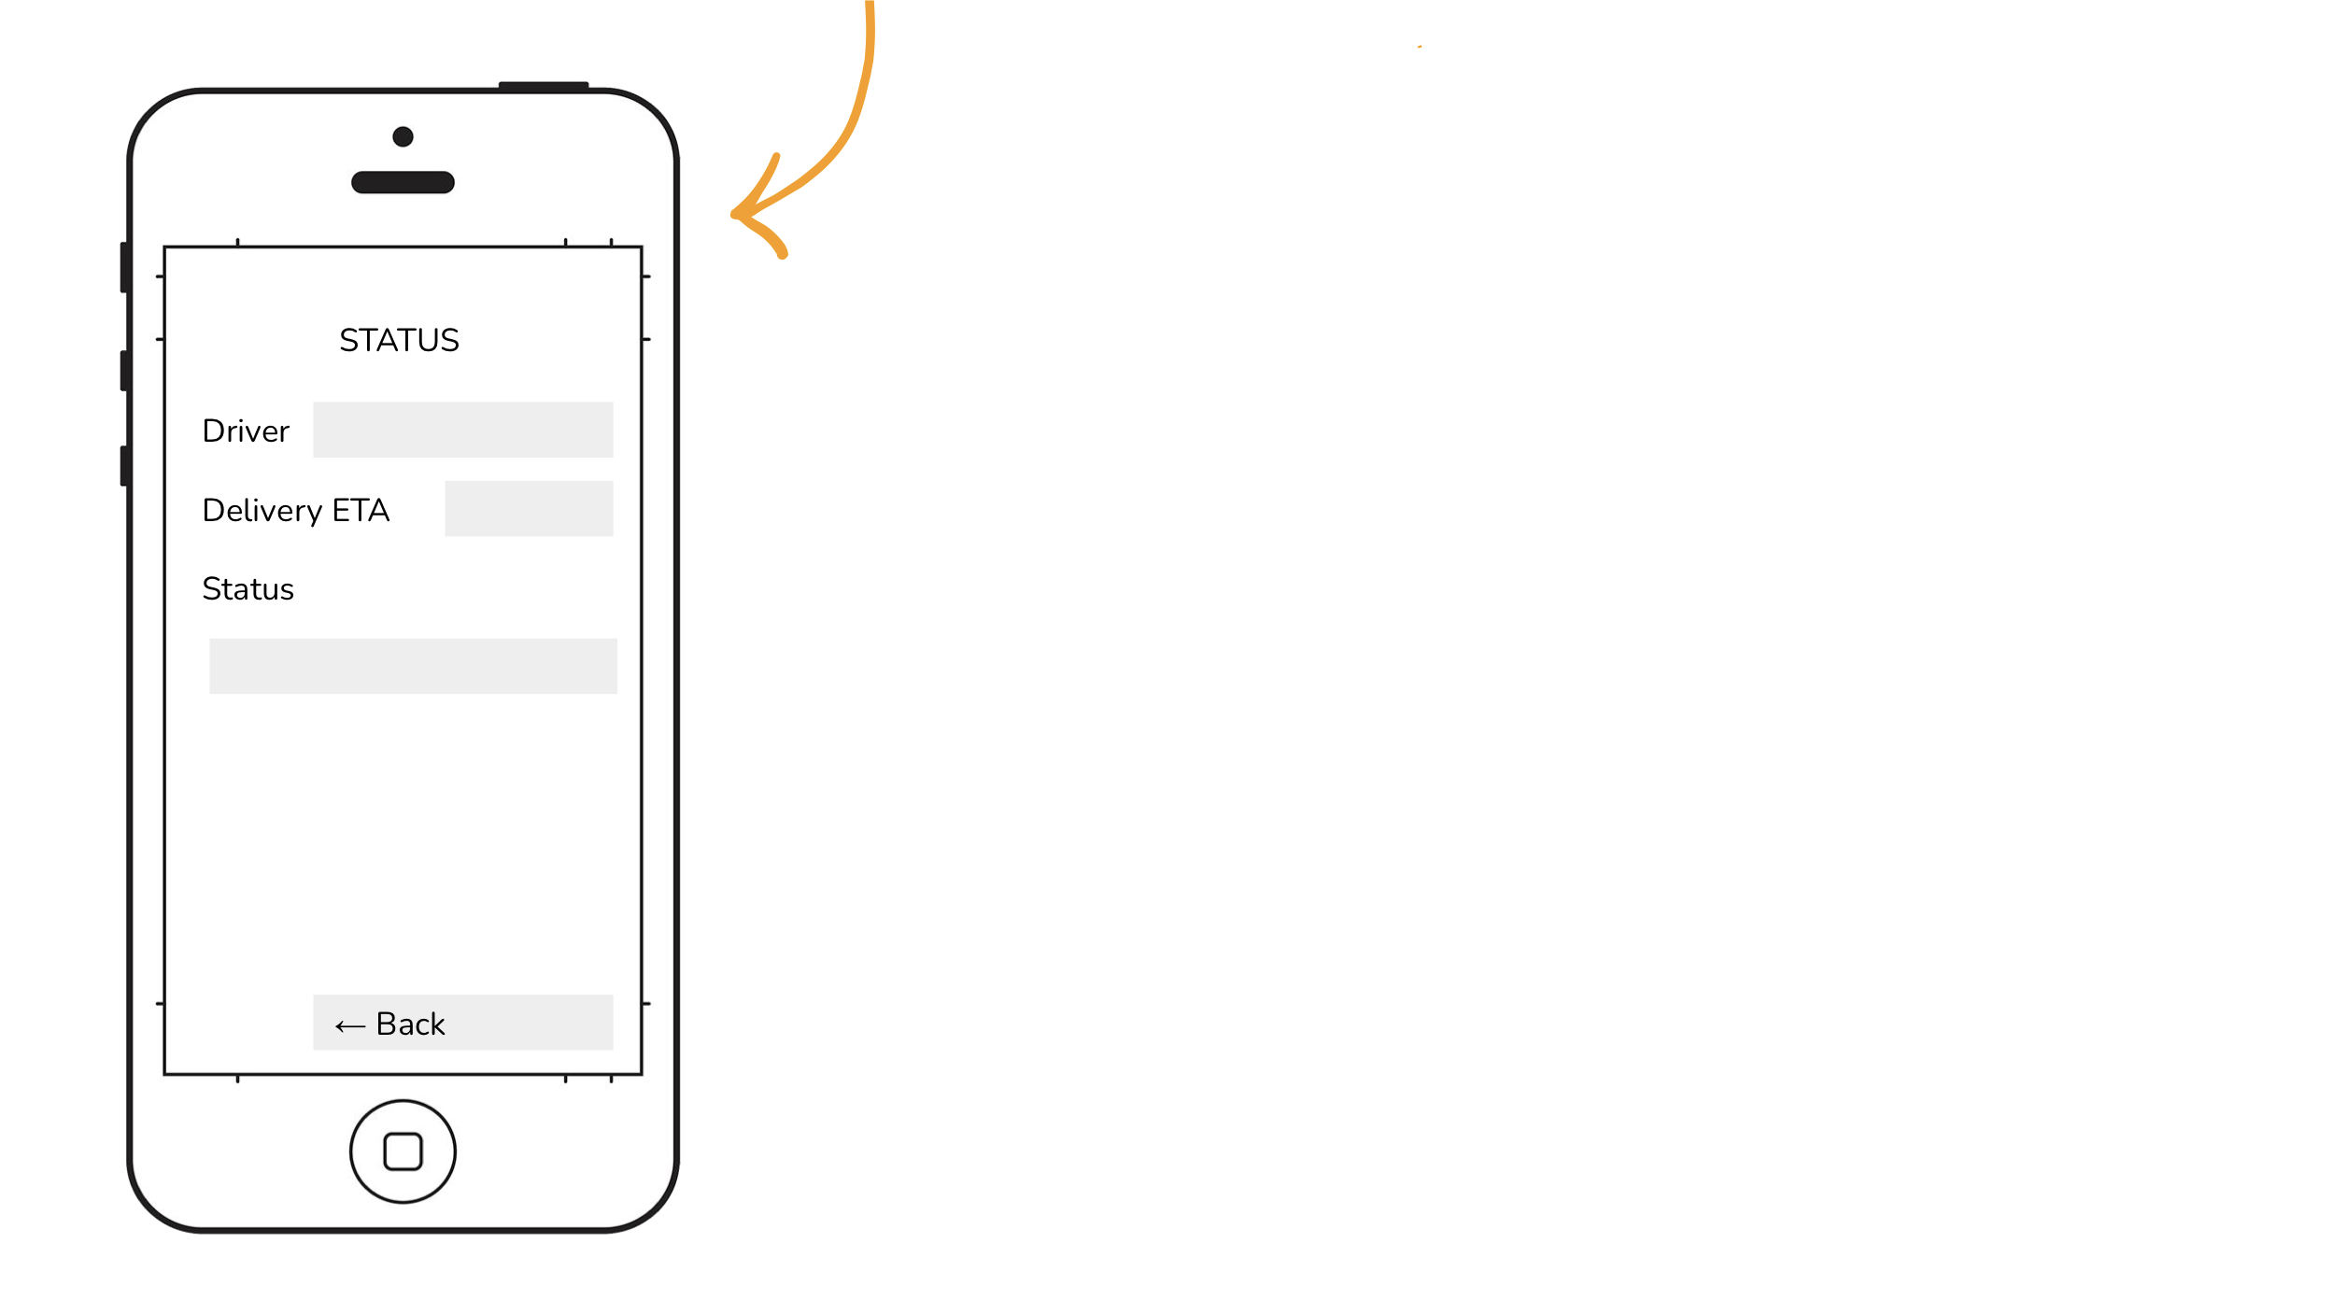

For our Final Mockup, we reviewed our low fidelity prototype from Iteration 2 and decided to sketch it out into a higher fidelity to better visualize the application. On the Create an Account page, we broke down the user’s address into more logical components like street address, city, state, and zip code. In addition, we added a Preferences page to capture the family size of the user in order to account for how many meals would need to be delivered at once. For convenience, we also added a feature to allow users to request multiple deliveries at once. Finally, to account for more inclusivity, we added a feature to account for dietary preferences or additional notes if a user has special needs for their meals. With this iteration, our design expanded with more details on ways we could better meet our usability goals.

**Storyboard:**

**Iteration 1:**

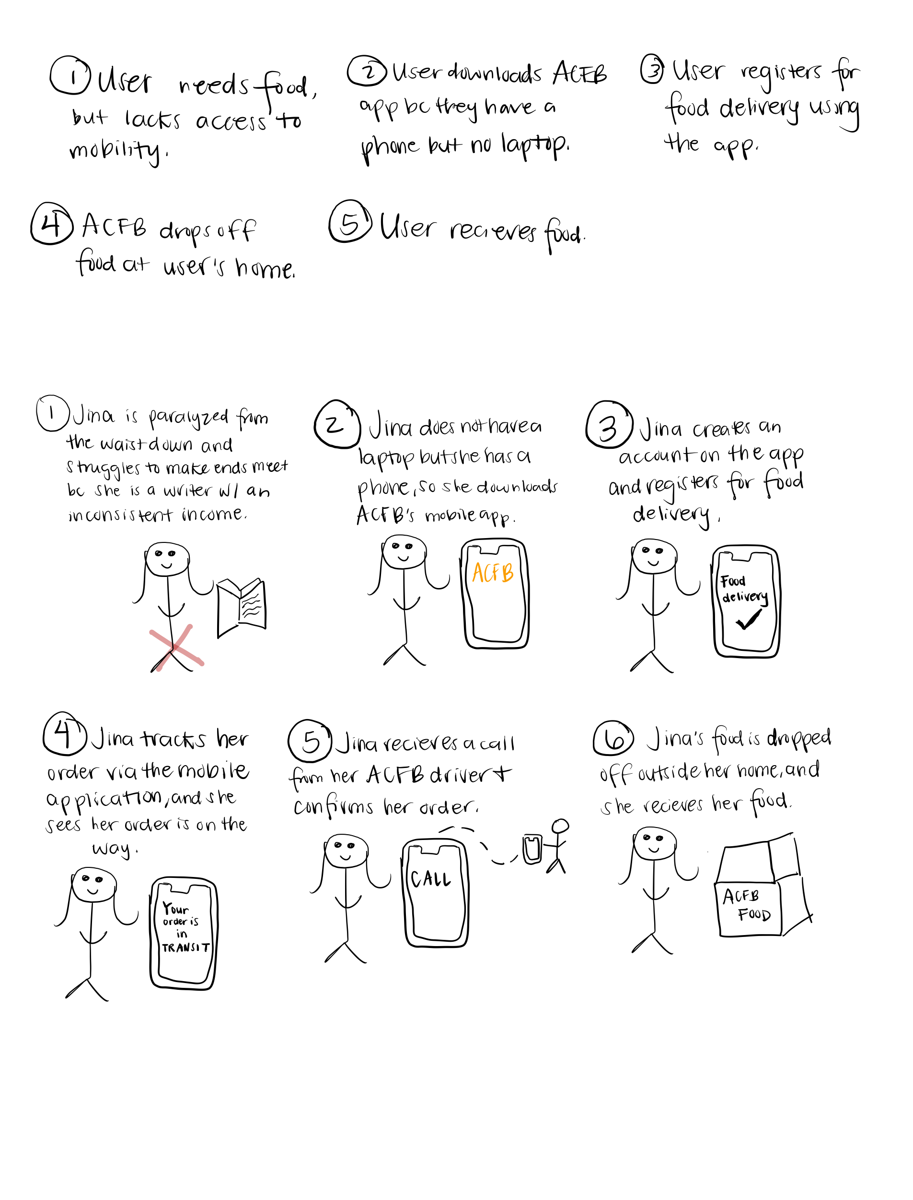

In our first iteration of our storyboard, we listed 5 steps of our primary stakeholder and the event flow of her interacting with the design alternative: mobile application. We wanted to first detail the basic steps of a primary user.

**Iteration 2:**



WithIteration 2, we added sketches for each of the steps. In addition, we added a step of the primary stakeholder, Jina, in this case using the Status Screen of the mobile application to track her food delivery. This storyboard follows Jina from struggling to have meals to receiving food from ACFB via their delivery service.

**Stakeholders:**

* Primary: ACFB Users (Food Insecure) who use the application, ACFB who manages the mobile application, Volunteers who manage the delivery system
* Secondary: Delivery Drivers
* Tertiary: Families of the users of the application

**User Scenario:**

*Jina is 40 and is paralyzed from the waist down. She currently lives by herself in an apartment and her family lives 1 hour away from her. She has friends and neighbors who check in on her occasionally. She works as a freelance writer and does not have a steady income. She has not been getting income for the past 3 months and needs to go to a food pantry to pick up food for herself. She could ask her neighbors or friends to help her, but she feels uncomfortable asking for their help all the time. Because she is disabled, it is hard for her to get around places. Because she’s on a tight budget, she doesn’t own a laptop, but she does have an iPhone 7 and access to the internet. She is struggling to make ends meet, so she decides to use ACFB’s mobile application to access their delivery service to the disabled facing food insecurity. She downloads the app, creates an account, sets up a time and date for delivery and fills in her address and food preferences to get the food delivered. She registers to get a food delivery in two days in the evening for one person with vegetarian meals only. On the day of the delivery, she tracks the status of his food delivery via the application and can see her driver is Mark and that her food is currently in transit to her home. As Mark leaves ACFB to her home, she gets a call from him. He confirms her address and tells her that he will arrive in the evening. The doorbell of her apartment rings, and she opens the door to receive her requested food. She thanks the delivery volunteer and closes the door. Because Jina lives by herself, she doesn’t have a family to feed, but she receives food for herself and is content with the delivery service.*

## Design Alternative 3: Text Service

The text service option would involve a system where users are able to contact ACFB through text in order to request meal delivery. Although ACFB already has a text service that allows users to find a food pantry near them, this one would allow for food delivery specifically. This design would be helpful based on evidence from P1 (see appendix B) that proxy users have access to cell phones, prefer to receive communication through text messaging, and prefer to have food delivered to them rather than picking it up. The flyers could be placed in areas that are experiencing growing food insecurity, such as the suburbs of Atlanta, and the delivery option could make up for the lack of accessible public transportation in those areas that we discovered as a part of P1. This design would be more accessible to users who have access to a cell phone but not internet connection, and would also allow users to communicate more directly with ACFB than other design alternatives. This design also uses a medium that users should already be familiar with, and therefore would be more simple to use than other design alternatives.

**Iteration 1:**

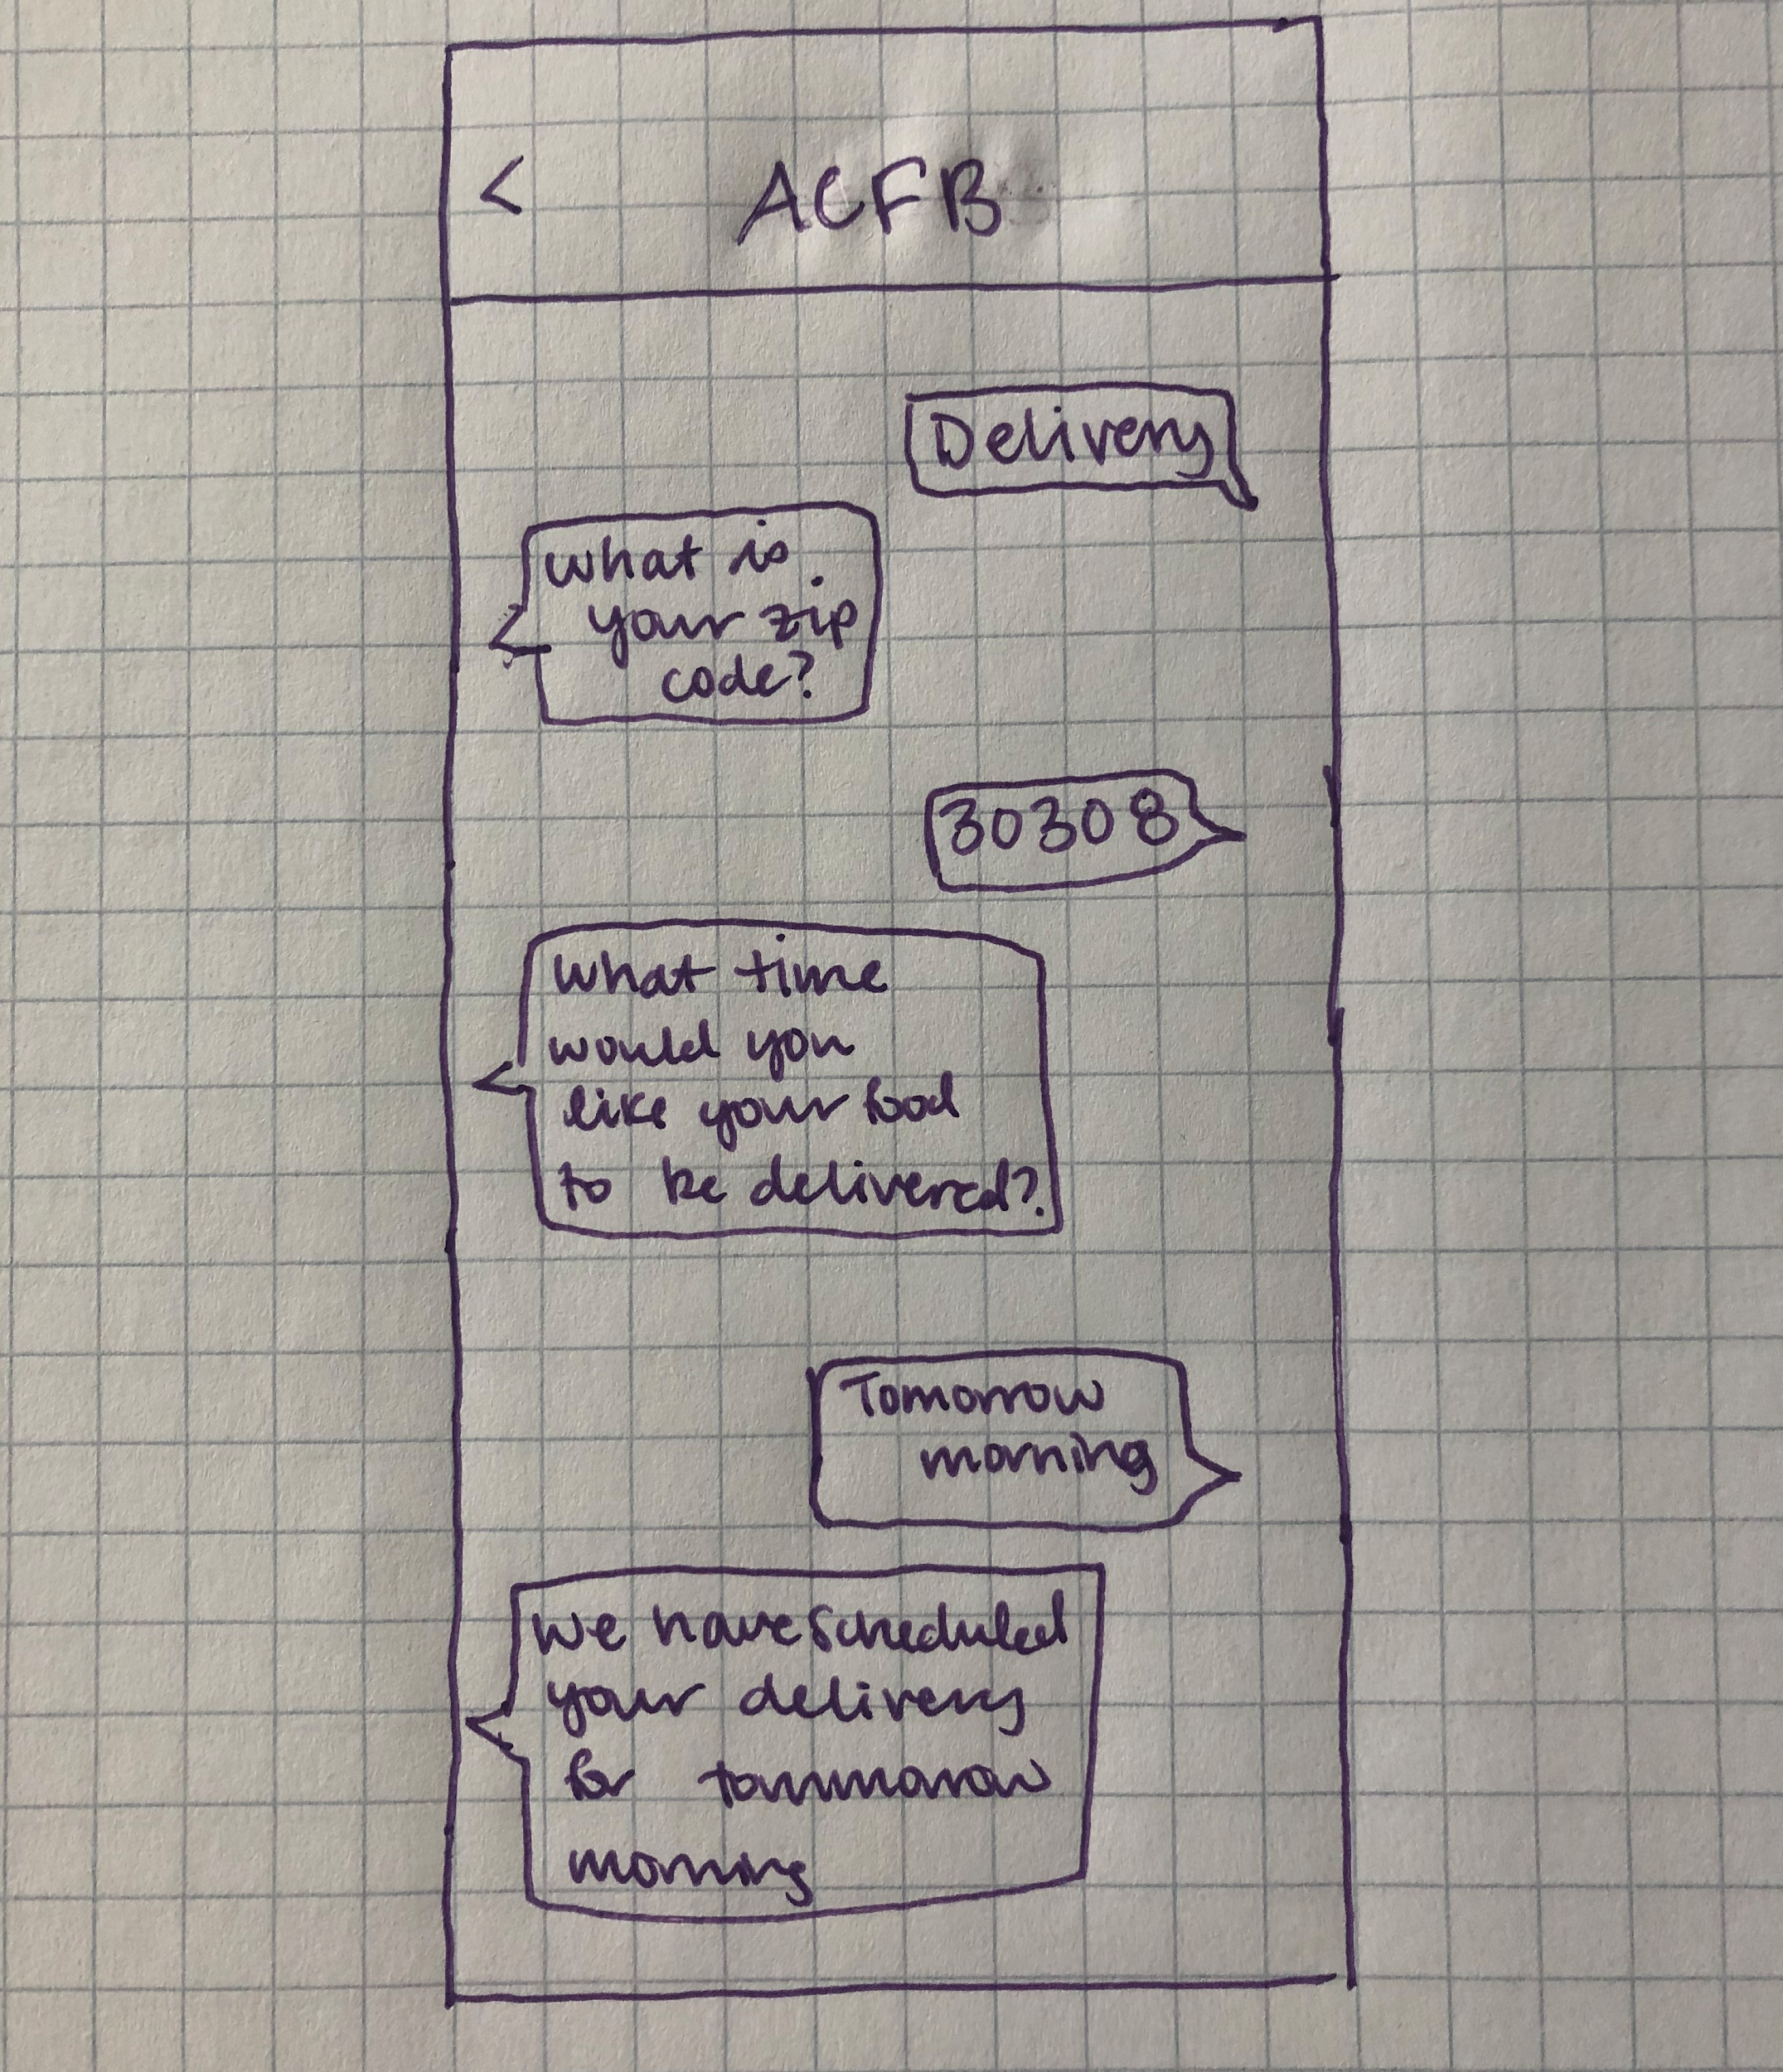

This prototype is a simple low-fidelity sketch outlining the basics of what this design would look like and how it would act. It shows how the user would initiate contact with the system and input their area and preferred delivery time, and how the system would schedule the delivery.

**Iteration 2:**

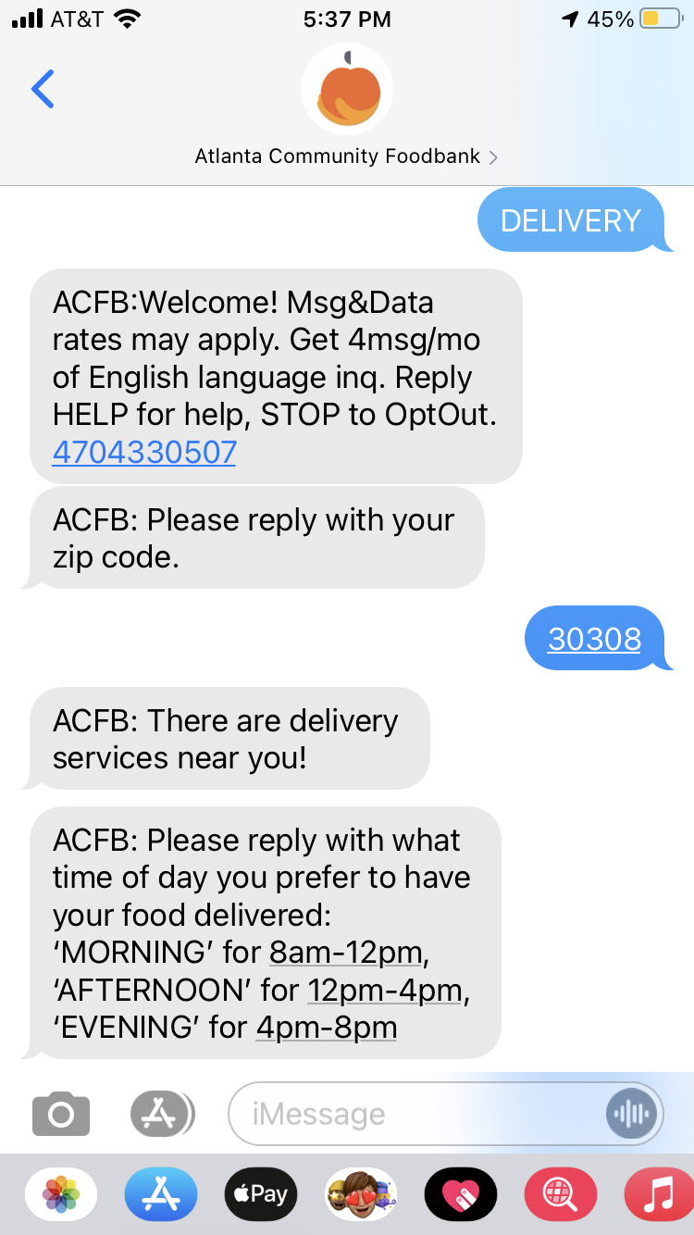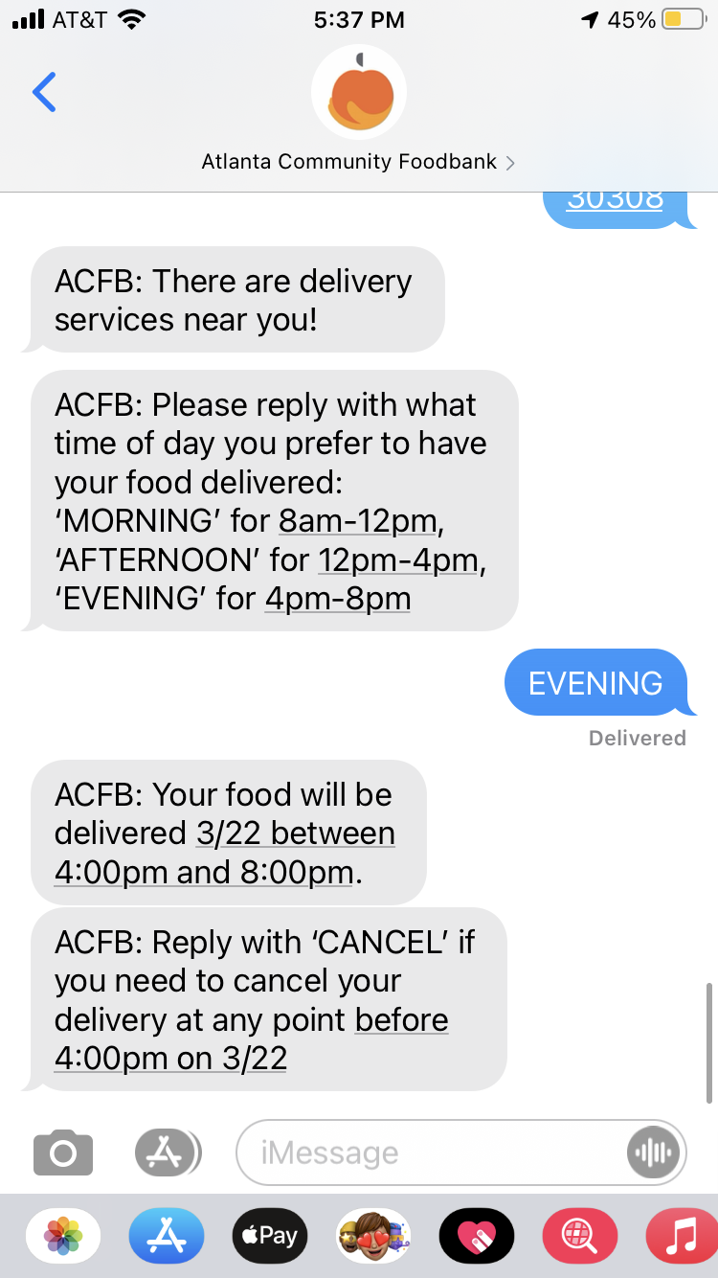

This prototype was another low-fidelity prototype made through texting a Google Voice number in order to model exactly how the system would respond to a user. It is a separate text service from the already existing service, and allows users to specifically request delivery. It first involves the user sending their zip code, in order to check if there is an ACFB service that delivers to their area. If there is not a delivery service in their area, it will direct them to the nearest ACFB pantry. If there is a delivery service to their area, it will ask them what time of day they prefer to receive their delivery. It then schedules a delivery for the next available time slot in their area, notifies the user, and gives them an option to cancel before their delivery time slot.

**Iteration 3:**

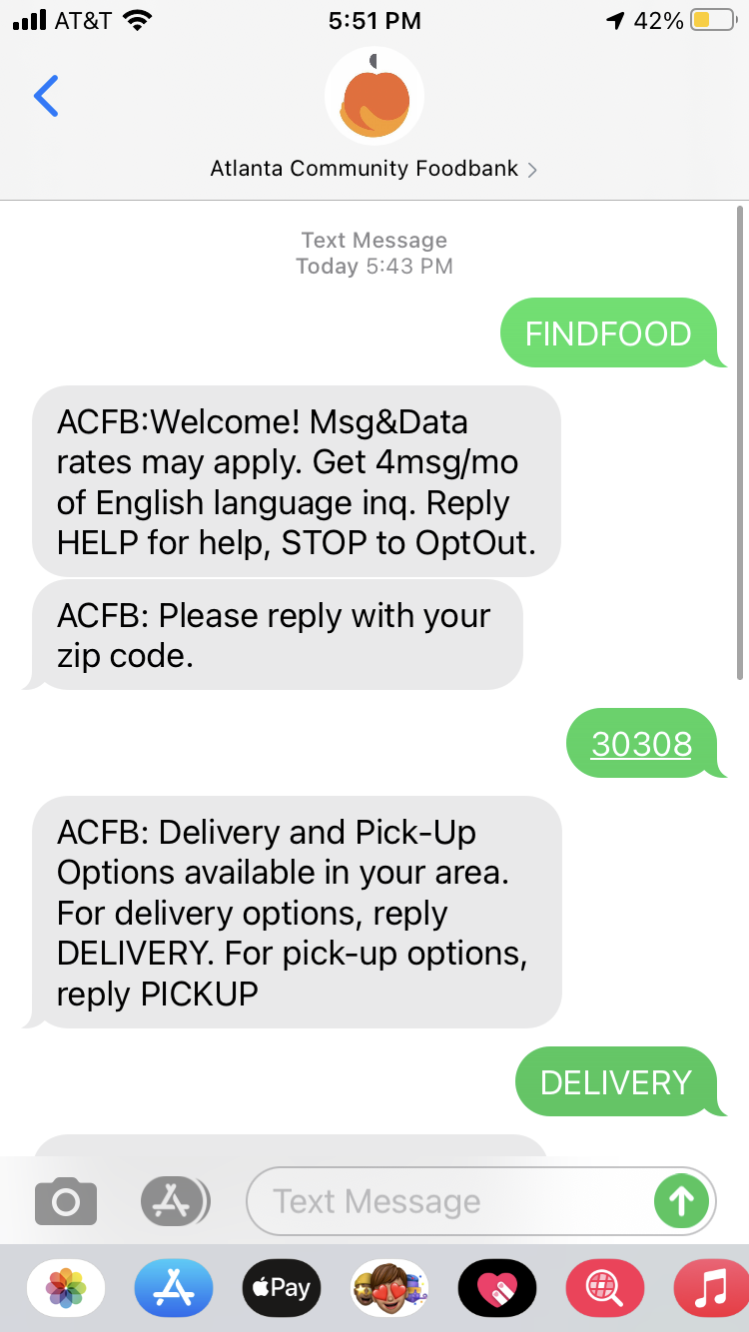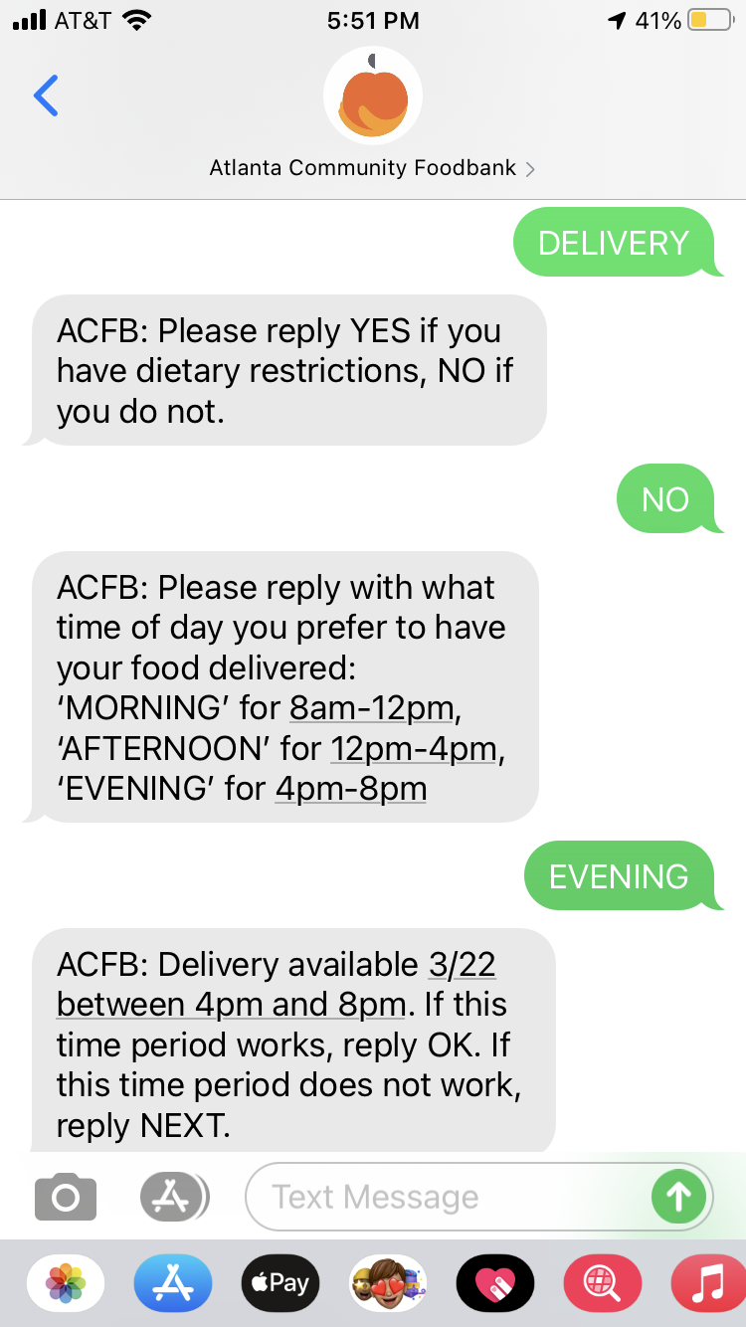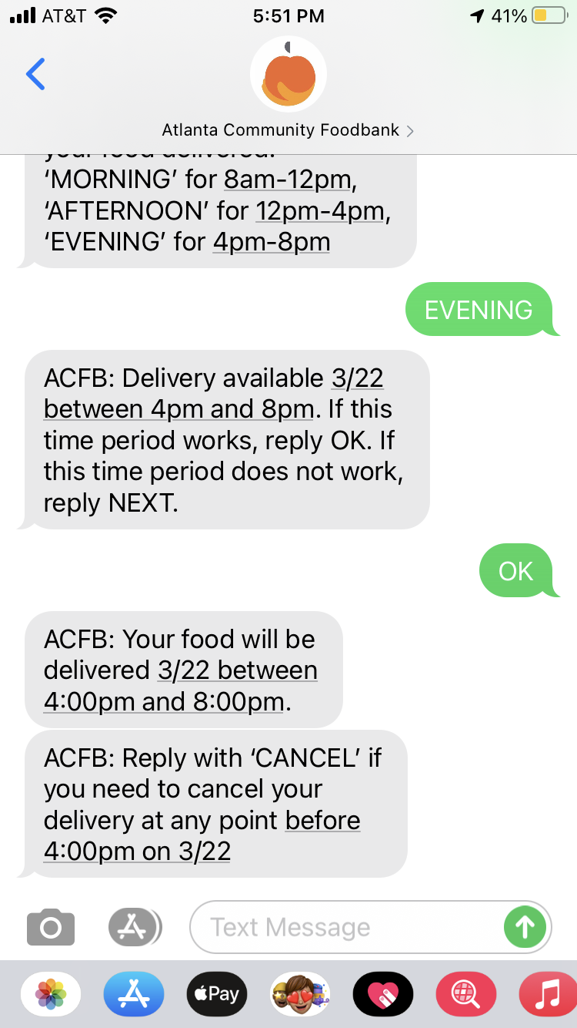

This prototype is another low-fidelity prototype made through texting a Google Voice number in order to model exactly how the system would respond to a user. This design is an addition to the already existing text service, and allows users to identify all options provided by ACFB in their area before giving the user the option to request the delivery option specifically. If delivery is not an available service in their area, they will only receive a text saying that pickup from nearby pantries is an option. If delivery is available in their area and they request that option, the system will again ask the user what time they prefer to receive their food, and schedule the delivery with an option to cancel before their delivery time slot.

**Iteration 4:**



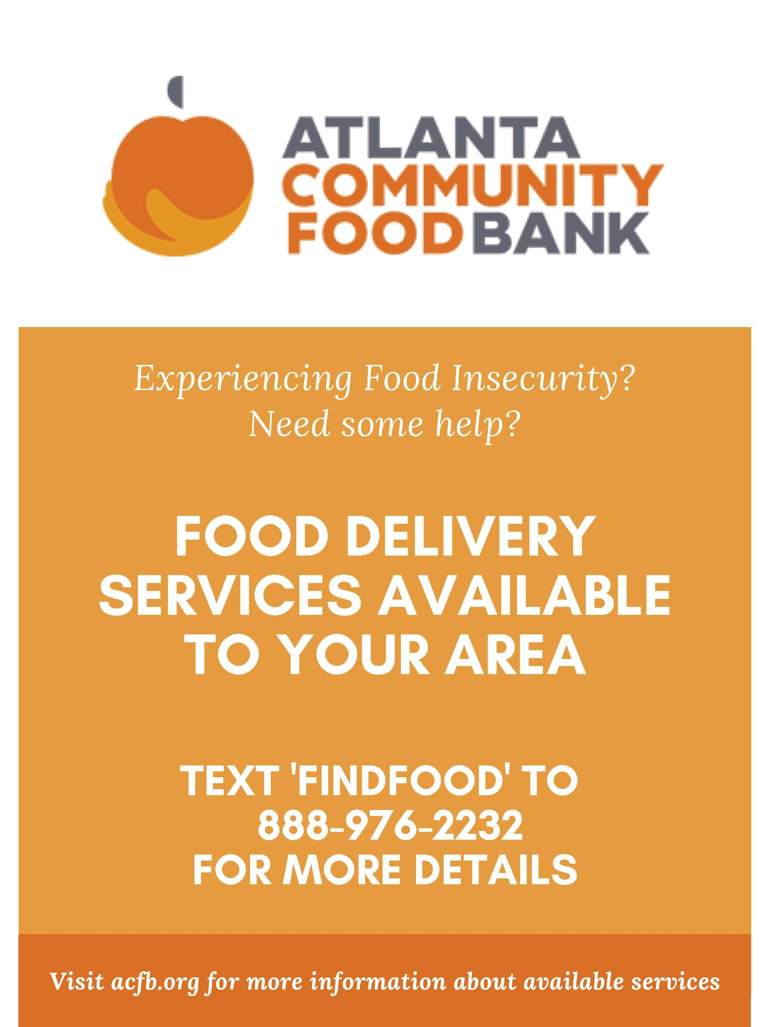

This prototype is another low-fidelity prototype made through texting a Google Voice number in order to model exactly how the system would respond to a user, as well as a sample flyer made through Canva. This design is similar to Iteration 3, but includes a flyer in order to spread awareness for the service. This allows more users in areas that have delivery services to be aware of and take advantage of those services, fulfilling ACFB’s mission of helping the community.

**Final Mockup:**

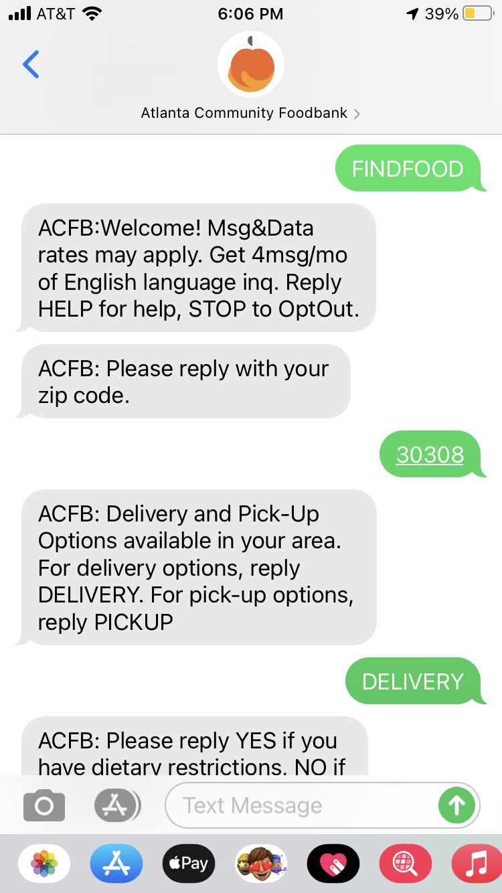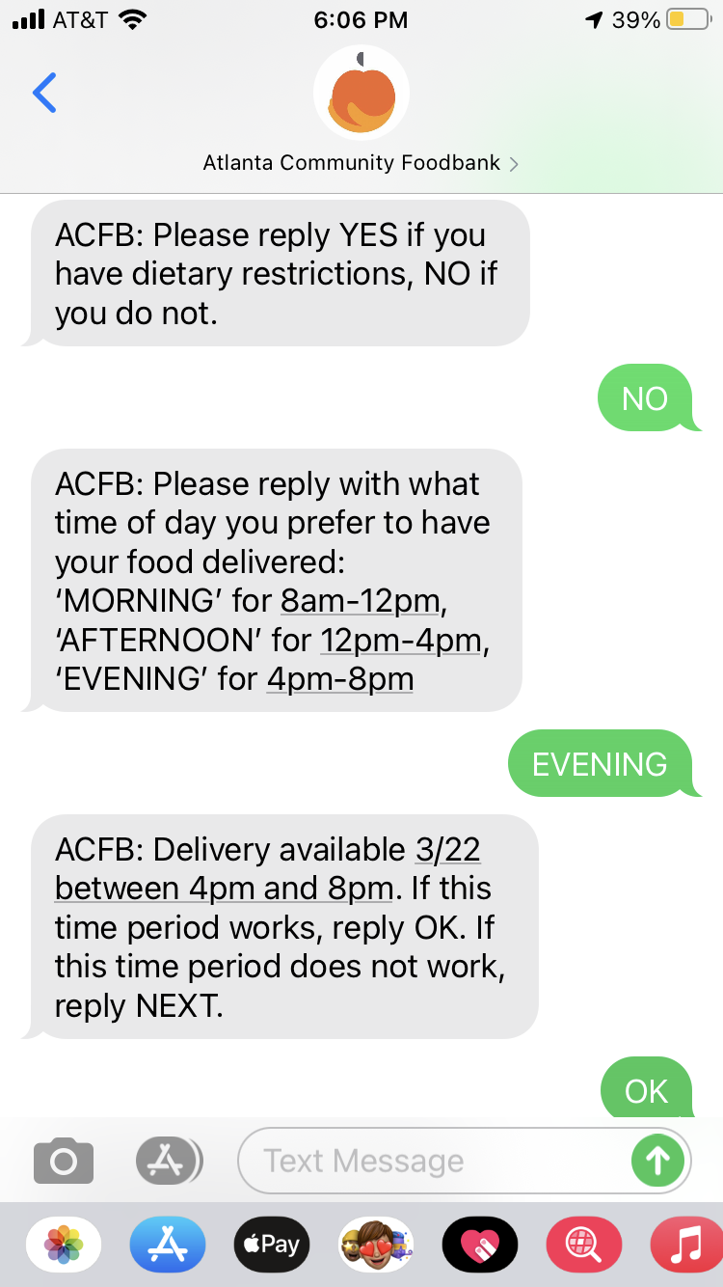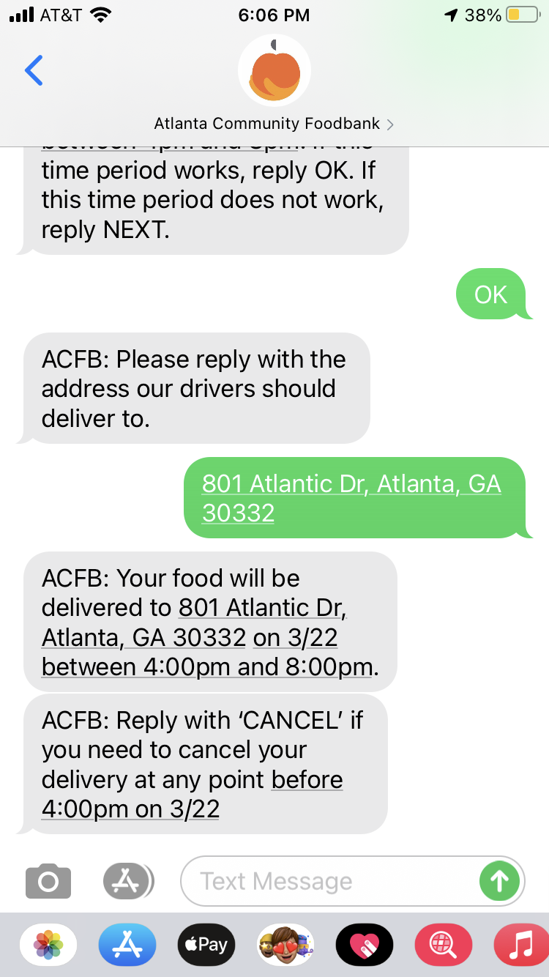



Our final mockup is another low-fidelity prototype made through texting a Google Voice number and a sample flyer made through Canva. It is similar to Iteration 4, but expanded horizontally to include a place for the user to input an address to have their food delivered. This system would include some sort of validation that the address is both a real address and within the previously stated zip code.

**Stakeholders:**

* Primary: ACFB Users (Food Insecure), Volunteers who deliver, Organizers behind the delivery system, ACFB outreach coordinators, ACFB
* Secondary: Children in food insecure families, rideshare drivers
* Tertiary: People who donate to ACFB

**Storyboards**

**Iteration 1:**

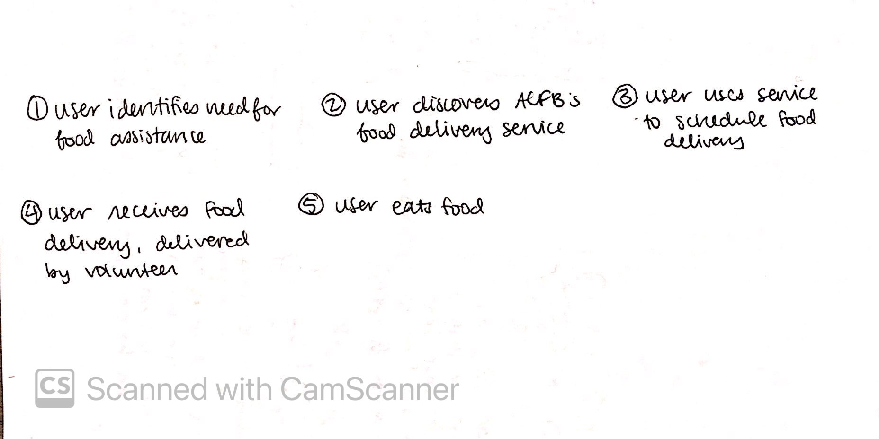

Our first iteration is a simple outline of how a user might interact with the system. We included two primary users in this scenario, a user who requires food assistance and a volunteer who is delivering food for ACFB, and shows how a user who requires food assistance could use ACFB to fulfill their needs and the volunteer would assist in this process.

**Iteration 2:**

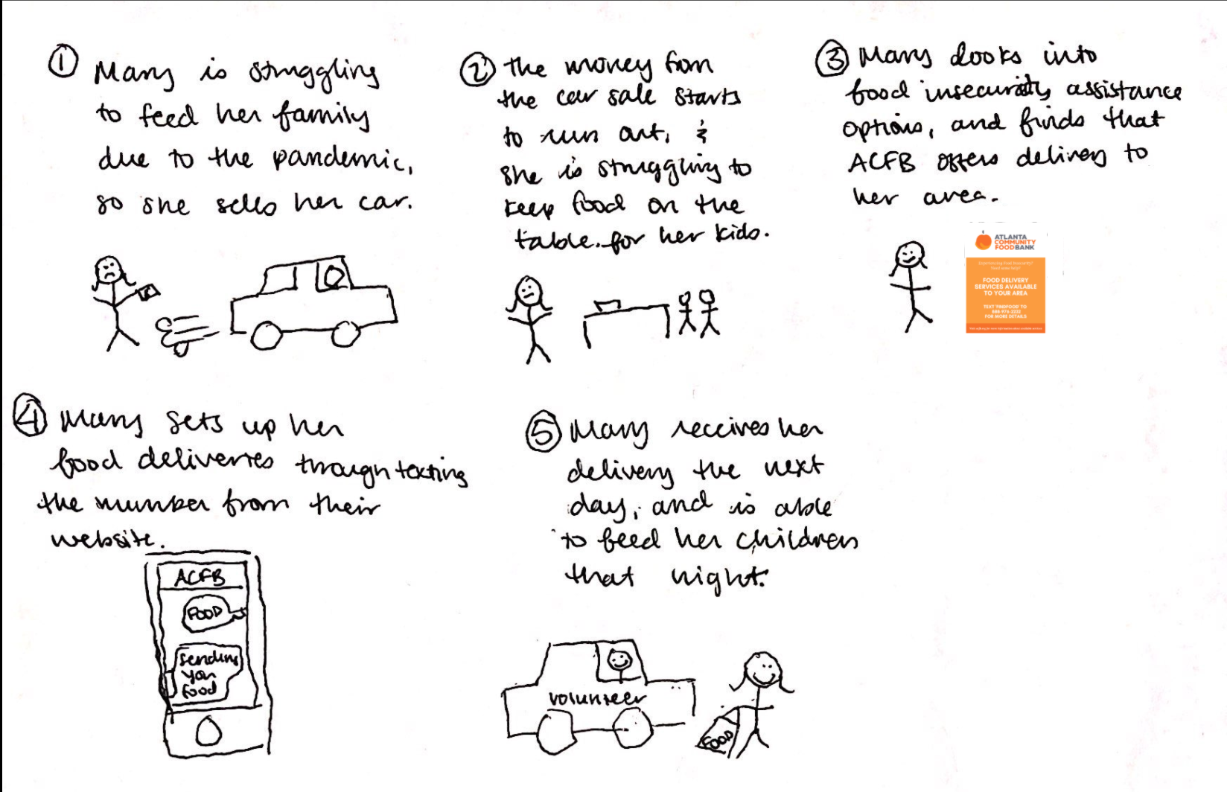

Our second storyboard iteration shows more details as to how the user who requires food assistance interacts with the system, including how she discovers the service provided and contacts ACFB to receive assistance. We based our user scenario on this storyboard.

**User Scenario**

*Mary, 32, works at a local store in a suburban Atlanta city. At the beginning of the COVID-19 pandemic, her store had to cut its hours and she has been working less and getting paid less ever since then. She has been struggling to make ends meet, and sold her car in order to pay for food for her and her two children. The money she made from the sale quickly ran out, however, and Mary has been looking for some assistance since then. She saw a flyer for ACFB’s services, and texted the number she saw on the flyer. Through this number, she found out that there wasn’t a ACFB pantry within walking distance of her home, but that ACFB does deliver to her neighborhood. She signed up for a delivery by texting the number listed on the flyer. The ACFB texting system followed up with several texts including asking for her zip code in order to check if her location was deliverable, if she had any dietary restrictions, and a list of times, morning, afternoon, or evening, that would be convenient for her to have her food delivered, and following the prompts, a ACFB volunteer delivery driver brought the food to her address the next day. With this system, she was able to feed herself and her family when they would not have had food otherwise.*

**Evaluation Criteria**

We could evaluate our prototype through testing proxy users’ experience as they interact with the prototype interface. We could accomplish this through asking proxy users to use our prototype to schedule food deliveries, and then ask them questions about the ease of use and how this application could benefit them. We can also record the number of successful delivery sign ups versus attempted delivery sign ups, and how likely proxy users would be willing to use an interface similar to our prototype.

# Design Assessment

## 

## Requirements

**Functional**: Information collection using the text service would be the most difficult. Gathering information through texts is not the easiest as users may become confused on directions and options. The website and mobile application could help mitigate this as the interface would be richer and more information could be presented. The same applies to availability feedback. As the information provided on a website or mobile app is more elaborate, the feedback from the system can be more comprehensive.

**Non-Functional**: The website and mobile app would have a higher learning curve, especially for those not familiar with technology, as there is more information and options on those interfaces. The texting service would be the most accessible as it doesn’t require Internet or smartphone access. The texting service would be more reliable because it doesn’t rely on being connected to the Internet and is more secure. The website or mobile app would likely be more useful because it is able to provide more information and feedback.

## Design Criteria

| **Criteria** | Website | Mobile App | Text Service |
| --- | --- | --- | --- |
| Sustainability: | 3.4 | 2.8 | 3.8 |
| Convenience: | 3.6 | 4 | 4.4 |
| Inclusiveness: | 3.6 | 2.8 | 4 |
| Communication: | 4.6 | 3.6 | 3.6 |
| Utility: | 4.8 | 4 | 2.6 |
| Cost: | 3.4 | 2 | 4.6 |
| Efficiency: | 4.2 | 4 | 3.2 |
| Learnability: | 3.8 | 3.2 | 3.6 |
| **Total**: | **3.925** | **3.3** | **3.725** |

Our design criteria includes four criteria from part 1: convenience, inclusiveness, communication, and utility, as well as additional criterias of sustainability, cost, efficiency, and learnability. We added sustainability because it is important to measure how well the interface can be supported and maintained, especially in the future, as ACFB is a non-profit organization and is mainly supported through volunteers. Cost was added for this reason as well because if the system can’t be funded then our stakeholders will not benefit. Efficiency was also taken into account as a measure of how quickly and effectively users set up food deliveries with ACFB. Learnability is also a part of this process as a measure of how long it takes users to learn how to navigate the system.

To evaluate each design, we separately rated each design using the eight criteria that we developed on a scale from 1-5, with 5 being the best for that criteria (most sustainable, most efficient, least costly, etc.). We then averaged the ratings for each design and criteria and summed the ratings for each design, giving the design alternatives total score. The website scored the highest with a score of 3.925 then the text service (3.725) and then mobile app (3.3). We will be using the website design alternative for the rest of the project.

# Reflection

For Part 2, we moved away from defining and exploring our problem space to actually designing the interfaces that would serve as solutions. We started the process by creating “How Might We” statements in order to reframe the problem space into design opportunities. After coming up with three of these statements, we began identifying design alternatives as a group. Each of us generated ideas by ourselves via the Crazy 8’s method, and then shared with one another through discussion and a miro board. We then grouped our design alternatives by similar media to narrow down what approach we should take for our design alternatives. From here we were able to pick three design alternatives: a mobile app, website delivery service implementation, and a texting service. Being able to freely generate ideas and coming together to discuss them allowed us to consider a wide range of design alternatives instead of focusing on one or two from the beginning, and we found that this was beneficial in keeping ourselves open to various design alternatives.

Crafting P2 incorporated many design iterations. For each design alternative, we created initial prototypes, and then analyzed these initial prototypes for each design option, and came up with ideas for how to improve them based on background evidence, survey data, and usability goals from P1. For example, when we were iterating on our design for the text service, we realized that, based on our proxy survey data, 30% of users do not have access to transportation. From this information, we realized that if we wanted to make our interface accessible to our users, people facing food insecurity with a lack of access to transportation, we would need to make our delivery service only available to people who are at a distance from the nearest food pantry or are disabled. We then iterated on our designs, made new low-fidelity models, and critiqued them again and repeated this process until we could no longer come up with ways to improve the designs. We also developed additional design criteria, including sustainability, cost, efficiency, and learnability. These criteria measure how well the system could be maintained and how effectively users utilize the system. This invoked more thought on the iteration process as we believed our designs needed to be evaluated on further criteria and measured additional elements our previous criteria did not cover. Although we did use multiple low and high-fidelity prototyping techniques, we could have used index cards to design a website prototype, having each card represent a different screen in the website. For the text service, we could have used a video prototype to show a demonstration of how a person would sign up for the delivery service through text message. For the mobile application, we could have created a high-fidelity, interactive prototype through invision, working similarly to an actual mobile application. With more time, we could explore our current design alternatives more in depth and develop criteria that would provide a more comprehensive evaluation of our designs.

**Appendix A**

**P1:** <https://docs.google.com/document/d/1xPwj-8n6ybIxlUL9jWf3tjUWX3grjBE5ut9smDzaKVw/edit?usp=sharing>

**Appendix B**

**P1 Survey Results:**

<https://drive.google.com/file/d/1YgzjNFkI0Roi-jQKDPkMm1vDvI4W_RZN/view?usp=sharing>